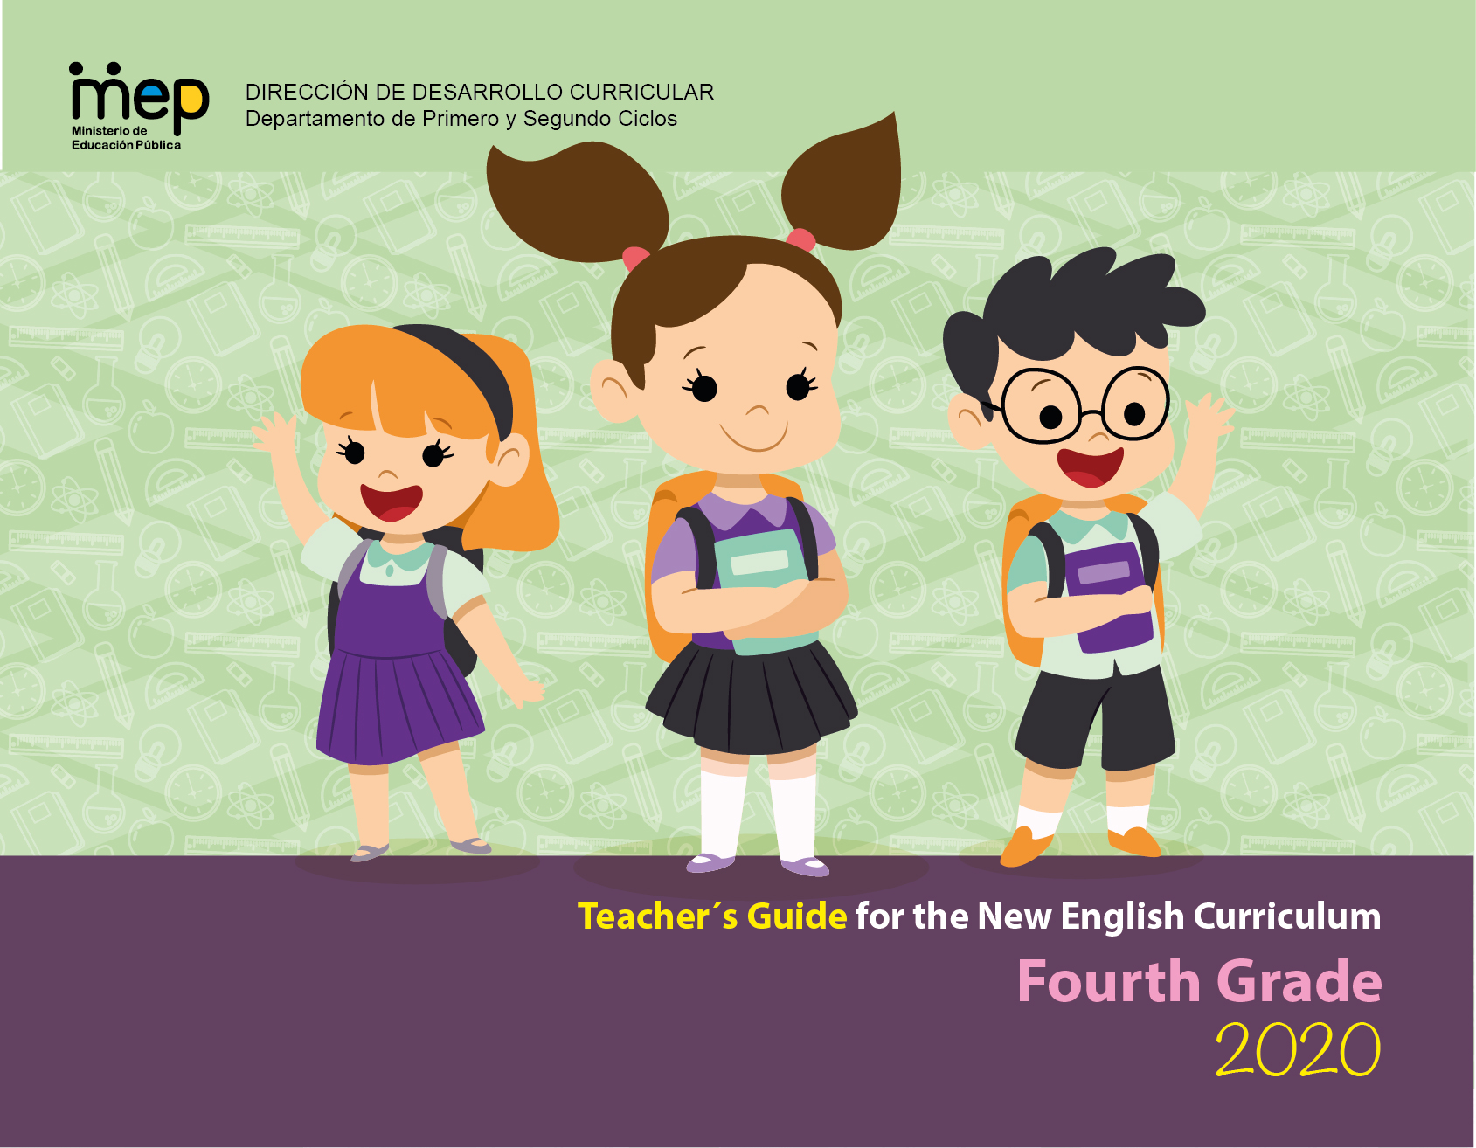

Unit 3 Farm to Table

|  |  |  |  |  |
| --- | --- | --- | --- | --- |
| **Level 4th Unit 3**  **Scope and Sequence** | | | | |
| **Scenario: Farm to Table** | | | | |
| **Enduring Understanding** | Fertile land and farming are necessary to have fresh food on the table and provide us with the ingredients for a good meal. | | | |
| **Essential  Question** | What does it take to have fresh food on our table? | | | |
| **Assessment and Goals** | | | | |
| **Week 1** | **Week 2** | **Week 3** | **Week 4** | **Week 5** |
| **Theme**   1. At the Farm | **Theme**   1. Let´s Go to the Farmers’ Market | **Theme**   1. Let´s Make a Meal | **Theme**   1. May I Have your Order? |  |
| **Assessment:**  **L.1.** Recognizes the main points in simple, clear, and short audio announcements and messages.  **R.PA.1.** Reads words and sentences blending English graphemes and phonemes.  **SP.1.** Talks briefly about familiar topics.  **W.1.** Uses simple sentences and expressions to describe things.  **Goals:**  **L.1.** understand the main points in simple, clear, and short audio announcements and messages.  **R.PA.1.** decode English graphemes and phonemes using knowledge of word parts, syllabification and phonemic awareness.  **SP.1.** talk briefly about familiar topics, such as food growing and harvesting.  **W.1.** use simple sentences and expressions to describe such things as their surroundings, their daily activities, and the people around them. | **Assessment:**  **L.2.** Recognizes the most important points in a straightforward talk or presentation.  **R.PA.1.** Reads words and sentences blending English graphemes and phonemes.  **SP.2.** Describes basic aspects of their day-to-day life.  **W.2.** Composes short sentences and notes for describing activities at the farm and food preferences.  **Goals:**  **L.2.** understand the most important points in a straightforward talk or presentation, accompanied with drawings and/or diagrams, provided there was some previous familiarity with the topic.  **R.PA.1.** decode English graphemes and phonemes using knowledge of word parts, syllabification and phonemic awareness.  **SP.2.** describe basic aspects of their day-to-day life, such as favorite foods and daily activities.  **W.2.** compose short sentences and notes for describing activities at the farm and food preferences. | **Assessment:**  **R.1.**Recognizes much of what is written in short, simple texts.  **R.PA.1.** Reads words and sentences blending English graphemes and phonemes.  **SI.2** Exchanges information about everyday matters using simple vocabulary (e.g., favorite food, recipe).  **Goals:**  **R.1.** understand much of what is written in short, simple texts on subjects with which they are familiar and/or in which they are interested.  **R.PA.1.** decode English graphemes and phonemes using knowledge of word parts, syllabification and phonemic awareness.  **SI.2** exchange information about everyday matters using simple vocabulary (e.g., favorite food, recipe | **Assessment:**  **R.2.** Locates important information in simple text.  **R.PA.1.** Reads words and sentences blending English graphemes and phonemes.  **SI.1.** Asks others about what they like to eat or drink.  **SP.3.** Presents with a group, a topic sentence and two to three details.  **Goals:**  **R.2.** locate important information in simple text (e.g., greetings on the bulletin board, or times and dates on a class notice).  **R.PA.1.** decode English graphemes and phonemes using knowledge of word parts, syllabification and phonemic awareness.  **SI.1.** ask others about what they like to eat or drink.  **SP.3.** present with a group, a topic sentence and two to three details. | **Assessment**  **Instruments for Process/Product**  **Week 6**  **Suggested Integrated Mini Project**   * **Mini book** |
| **Function**   * Describing farm activities, habits and routines | **Function**   * Describing things and places | **Function**   * Giving and following directions | **Function**   * Expressing preferences for ordering food |
| **Discourse Markers**  Linkers: Sequential - past tense  First, then, after that, finally | **Discourse Markers**  Linkers: Sequential - past tense  First, then, after that, finally | **Discourse Markers**  Linkers: Sequential - past tense  First, then, after that, finally | **Discourse Markers**  Linkers: Sequential - past tense  First, then, after that, finally |
| **Grammar & Sentence Frames**  Present simple  Personal pronouns (i.e., I, you, he, she, it) and adverbs of frequency (every day/week/Saturday, always, sometimes) to complete a given sentence.   * **I** get up early **every morning**. * **He/she** milks the cow **every day.** * **They** feed the pigs and chickens **every morning.**   Present continuous with adjectives modifying nouns (quantity, size, shape, color)   * My mother is watering the ornamental plants. * They are planting new lemon trees. | **Grammar &Sentence Frames**  Present simple in sentences with adjectives modifying nouns (quantity, size, shape, color)   * I want three big oranges. * I need three big carrots. * I want three cheeseburgers and a small size order of French fries.   Articles with Count and non-count nouns   * An apple/ apples * A horse/ horses * Milk / some milk * Salt / some salt | **Grammar & Sentence Frames**  Count and non-count nouns with some, much and many   * I need some sugar. * How much sugar do you need? * I need to buy many bags of coffee.   Sequence adverbs with imperatives   * First, boil some water. * Second, add the spaghetti. | **Grammar & Sentence Frames**  Wh-questions with present simple   * What do you usually buy at the farmer’s market? * What do you usually order at the restaurant? * How do you prepare that recipe?   Wh-questions with present continuous   * What are they doing? * Where are you going? |
| **Phonemic Awareness**  Decoding English graphemes that sound different in Spanish:   * A (s**a**lt, **a**pple, w**a**iter) * H (**h**ouse, cas**h**ier) * I ( m**i**lk, p**i**neapple) * J (**j**ar, **j**uice) | **Phonemic Awareness**  Reading contractions   * Doesn’t, don’t, didn’t, aren’t | **Phonemic Awareness**  Consonant blends   * /pl/:planting, plowing * /st/:staying, stirring * /tr / transport, trailer | **Phonemic Awareness**  Practicing minimal pair sounds**: s / z**  **sip / zip**  **sue / zoo**  **place / plays**  **rice / rise**  **ice / eyes** |
| **Vocabulary**  1. At the farm  Preparing the fields:   * seeds, tools, dirt, fertilizer, pesticides   Growing the crops:   * weeding, cutting, pruning, digging, weather, watering   Farm activities   * Planting/growing * Gardening * Cow milking * Harvesting, Feeding   Transporting:   * baskets, boxes, wheelbarrow, trucks, warehouses   Processing:   * jars, packing, storing, factories | **Vocabulary**  2. Let´s go to the farmers’ market  Selling:   * stores, markets,   Costa Rican crops   * bananas, oranges, pineapples, mangoes, vegetables, corn, * palm oil, chocolate, ornamental plants   Meats   * Pork, poultry, beef, seafood | **Vocabulary**  3. Let´s make a meal  Verbs   * Preheat, grease * Steam, boil, slice * Peel, chop, stir, * Add, serve | **Vocabulary**  4. May I have your order?   * Waiter, Waitress * Cashier, Order * Menu, Breakfast * Lunch, Dinner * Main dish, Bill * Side dish |
| **Psycho-social**   * Develops cooperation practices to solve problems * Communicates needs and desires effectively   **Sociocultural**   * Cultural differences in terms of habits and routines between urban and rural settings   **Idioms/phrases**   * The early bird catches the worm. (If you get up to work early, you will succeed.) | **Psycho-social**   * Shows willingness to work cooperatively   **Sociocultural**   * Polite forms to greet, say good-bye and address people in different settings/ farm/ friends/farmer’s market, restaurant   **Idioms/phrases**   * Green thumbs (Good at gardening) My dad was born with green thumbs. He´s great with plants. | **Psycho-social**   * Takes social responsibility for cultivating own food   **Sociocultural**   * Ways of expressing gratitude   **Idioms/phrases**   * To be starving( to be very hungry) | **Psycho-social**   * Values the work of farmers   **Sociocultural**   * Ways of expressing gratitude   **Idioms/phrases**   * To be starving( to be very hungry) |  |

|  |  |  |  |  |  |  |  |  |
| --- | --- | --- | --- | --- | --- | --- | --- | --- |
| **Term: SECOND** | | **Level: Fourth** | | | **Unit: 3** | | **Week:1** | |
| **Domain: Transactional** | | | | **Scenario: Farm to table** | | | **Theme: At the farm** | |
| **Enduring Understanding**: Fertile land and farming are necessary to have fresh food on the table and provide us with the ingredients for a good meal | | | | | | | | |
| **Essential Question: What does it take to have fresh food on our table?** | | | | | | | | |
| |  | | --- | | **Dimensions** | | **1.** **Ways of thinking ( X  )** | | **2. Ways of living in the world  ( )** | | **3. Ways of relating with others  ( X )** | | **4. Tools for integrating with the world  ( X )** | | | | | | | | | |
| **Learn to Know** | | | | **Learn to Do** | | | **Learn to Be and Live in Community** | |
| **Grammar & Sentence Frames**  Present simple  Personal pronouns (i.e., I, you, he, she, it) and adverbs of frequency (every day/week/Saturday, always, sometimes) to complete a given sentence.   * **I** get up early **every morning**. * **He/she** milks the cow **every day.** * **They** feed the pigs and chickens **every morning.**   Present continuous  with adjectives modifying nouns (quantity, size, shape, color)   * My mother is watering the ornamental plants. * They are planting new lemon trees.   **Vocabulary**  1. At the farm  Preparing the fields:   * seeds, tools, dirt, fertilizer, pesticides   Growing the crops:   * weeding, cutting, pruning, digging, weather, watering   Farm activities   * Planting/growing * Gardening * Cow milking * Harvesting, Feeding   Transporting:   * baskets, boxes, carts, trucks, warehouses   Processing:   * jars, packing, storing, factories   **Phonology**  Decoding English graphemes that sound different in Spanish:   * A (s**a**lt, **a**pple, w**a**iter) * H (**h**ouse, cas**h**ier) * I ( m**i**lk, p**i**neapple) * J (**j**ar, **j**uice) | | | | **Function**   * Describing farm activities, habits and routines   **Discourse Markers**  Linkers: Sequential - past tense  First, then, after that, finally | | | **Psycho-social**   * Develops cooperation practices to solve problems * Communicates needs and desires effectively   **Socio-cultural**   * Cultural differences in terms of habits and routines between urban and rural settings   **Idioms/phrases**   * The early bird catches the worm. (If you get up to work early, you will succeed.) | |
| **Assessment Strategies & indicators of learning** | **Goals** | | | **Pedagogical mediation/Didactic Sequence** | | | | **Time** |
|  |  | | | **Pre-teaching**  **Routine:** Checking attendance, checking in with Ls, T posts the Essential Question on the board, Can Do’s, and class agenda, etc.  **Warm up**  Vector de stock (libre de regalías) sobre Jigsaw Puzzle Game ...The class is divided into groups of four people. The teacher gives each team some pieces of a jigsaw puzzle and instructs them to assemble the puzzle as quickly as possible. The group who assembles the puzzle first, yells out the name of the occupation in the picture: “FARMER”.  Image result for activities at farm clipart**Activation of prior knowledge**  Learners observe the teacher as he/she sticks the picture of a farmer on the board and sets up a table with the images of different activities (Make sure you include activities done by different workers). Volunteers from the group go to the front and choose the images that represent what a farmer does at a farm and stick them next to the picture on the board. The teacher monitors and asks questions to the students to help them decide: “Does a farmer help sick people?” Does a farmer feed animals? Does a farmer teach at school?”  Vectores, imágenes y arte vectorial de stock sobre Milk Cow ...Fall Harvest Farmer Couple, Green Vegetables, Food Basket ...  Diseño de vectores de planta de maíz.  Cartoon Farmer Clipart Png  Farmer Watering Plants Clipart  Farmer Feed Cow Stock Vector (Royalty Free) 248386069  **Modeling**  Using the images from the previous activity, the teacher describes what a farmer does at the farm. For example, “The farmer is always busy. He does different activities during the day.  Farmer Feed Cow Stock Vector (Royalty Free) 248386069  He feeds the animals.  Vectores, imágenes y arte vectorial de stock sobre Milk Cow ...  He milks the cows.  Ilustraciones, imágenes y vectores de stock sobre Farmer Plant ...  A farmer plants seed.  Diseño de vectores de planta de maíz.  A farmer grows vegetables and fruits.  Farmer Watering Plants Clipart  He waters the plants.  Fall Harvest Farmer Couple, Green Vegetables, Food Basket ...  Farmers harvests their crops  Print Look after animals flashcards | Easy Notecards  A farmer collects eggs.  Ilustraciones, imágenes y vectores de stock sobre Farmers Drive ...  A farmer drives his tractor.  The teacher invites learners to repeat after him/her.  **Clarifying**  Learners observe the teacher as he/she distributes cards with the activities farmers do at the farm and the pictures representing each activity. Learners listen to the teacher saying, for example, *“A farmer grows vegetables and fruit.”* Then, the learners with the sentence (card) and the corresponding image run to the front. The rest of the class decides if the answer is correct.  Learners play “charades”. Volunteer students go to the front of the class and pick up a flashcard with a picture and phrase of an activity done at the farm. The teacher shows the flashcard to the students and he/she performs the action seen on the flashcard. The rest of the class guesses the activity. | | | |  |
| **L.1.** Recognizes the main points in simple, clear, and short audio announcements and messages.  **Indicator of learning:**  Recognizes farm activities in simple clear short audios | **L.1.** understand the main points in simple, clear, and short audio announcements and messages. | | | **Oral Comprehension**  **Pre-task**  The teacher introduces the goal of the lesson  Learners watch the video ‘I want to be a farmer’ <https://www.youtube.com/watch?v=WtH7hNKyOD8> and are asked to mention all the activities farmers do at the farm and that they see in the video.  Learners brainstorm the farm activities they saw in the video and teacher writes them down on the board.  Image result for activities at farm clipart  **Task-rehearsal**  The learners play “picture race”. The teacher asks two volunteers to participate on a competition. The teacher sticks on the board the flashcards used previously and says a sentence. For example, “My brother feeds the animals.” The two students have to run to touch the flashcard with the activity said by the teacher. Then, new volunteers participate in the game.  **Task completion**  Learners listen to the WhatsApp audio **“Karla’s day on her cousin’s farm”.** As learners listen, they have to circle all the activities Karla does at the farm. (Note: The teacher can record the audio or ask a friend to do it.)  **Script:**  Hi mom! How is dad? I’m so excited of being at the farm. My cousin Ericka is always busy, but she takes me everywhere she goes, and I help her to do her chores. We wake up early in the morning to milk the cows. I love Anabelle, the cow, and she gives a lot of milk. Then, we go to pick up the eggs. Aunt Lilly has many hens and chickens. They are so noisy! After breakfast, Ericka and I go to the field and help the uncle to plant seeds and pick up fruit. That’s my favorite part of the day because I get to eat delicious apples. Later in the afternoon, we water the plants and finally we have dinner and go to bed early.  I miss you, but I’m having so much fun here that I’m going to stay a little bit longer, if you don’t mind. Love ya! Kiss!   |  | | --- | | **What does Karla do at her cousin’s farm?**  **Instructions:**  Listen to the audio and circle all the activities Karla does during the day while being at her cousin’s farm. | | Proudly Stock Photos, Stock Images and Vectors (Page 2) | StockfreshCurved Apple Images, Stock Photos & Vectors | Shutterstock  Ilustración De Los Niños Felices Para Ordeñar Una Vaca Fotos ...Imágenes, fotos de stock y vectores sobre Hen Picking the Food ...  Girl Planting Seeds ClipartJohn Deere Cartoon Tractor Free Clip Art Girl Driving - Girl ...Little Girl Watering Plants ClipartFeeding Farm Animals Clipart |   **Task assessment**  The teacher sticks around the classroom the flashcards used during the modeling stage. The teacher describes the flashcards one by one. Students listen to the teacher’s description and point at the pictures.  The whole class assesses their achievement of the goal  **Achieved  Not yet** | | | |  |
| **SP.1.** Talks briefly about familiar topics.  **Indicators of learning:**  Recalls farm tools vocabulary.  Talks briefly about the tools farmers use by using complete sentences. | **SP.1.** talk briefly about familiar topics, such as food growing and harvesting. | | | **Oral Production**  **Pre-Task**  The teacher shares the goal of the lesson  How to Draw a Smiling Sun - Really Easy Drawing GuidesLearners watch the video ‘Farmers plant the seeds’ <https://www.youtube.com/watch?v=cRhGOdqWIIo>, and as they listen to the song, the teacher represents each part of the song with drawings  Ilustraciones, imágenes y vectores de stock sobre Dirty Hands ...  Free Seed Planting Cliparts, Download Free Clip Art, Free Clip Art ...Rain Clouds Drawing at GetDrawings | Free download A farmer plants the seeds The sun comes out to shine  The rain begins to fall The seeds begin to grow  Pin de Yesy Estrada en oficios y profesiones | Oficios y ...Fresh carrot growing in the field Royalty Free Vector Image  The vegetables are here The farmer digs them up  Free Food Cliparts Vegetables, Download Free Clip Art, Free Clip ...  Now it is time to eat  Using a power point presentation or flashcards previously used, the teacher presents vocabulary and expressions used at the farm and asks learners to repeat after him/her. For example,  Seeds clipart 3 » Clipart Station   * The farmer uses seeds to plant vegetables. * Library of shovels clipart library stock png files ▻▻▻ Clipart ...The farmer uses a shovel to dig the vegetables out. * A farmer uses a watering can to water the plants. * The farmer uses a basket to collect the eggs. * He uses a wheelbarrow to collect the vegetable. * Transparent Pouring Water Clipart - Garden Watering Can Clipart ...The farmer uses a bucket to milk the cows.   Bucket Drawing , cartoon milk pail transparent background PNG ...241,078 Basket Stock Vector Illustration And Royalty Free Basket ...  Wheelbarrow Clipart | Carretilla, Jardinería, Oficios  **Task-rehearsal**  The teacher sticks flashcards on the board. For example:  Cartoon Farmer Clipart PngVegetable garden png, Picture #652398 vegetable garden pngSeeds clipart 3 » Clipart Station  **A uses to**  **C:\Users\Gabriela Castillo\AppData\Local\Microsoft\Windows\INetCache\Content.MSO\80BDC15.tmp**Transparent Pouring Water Clipart - Garden Watering Can Clipart ...Cartoon Farmer Clipart Png  **A uses to**  Ilustración De Los Niños Felices Para Ordeñar Una Vaca Fotos ...  Bucket Drawing , cartoon milk pail transparent background PNG ...Cartoon Farmer Clipart Png  **A uses a to**  Some volunteers go to the front and create sentences orally using the flashcards as stimulus. The rest of the class provides help to their peers if necessary.  The class is divided into pairs, and the teacher continues playing with the flashcards, inviting learners to produce sentences.  **Task completion**  The learners get the handout below:   |  | | --- | | Seeds clipart 3 » Clipart StationBucket Drawing , cartoon milk pail transparent background PNG ...  Cartoon Farmer Clipart Png  Library of shovels clipart library stock png files ▻▻▻ Clipart ...  241,078 Basket Stock Vector Illustration And Royalty Free Basket ...  Wheelbarrow Clipart | Carretilla, Jardinería, OficiosTransparent Pouring Water Clipart - Garden Watering Can Clipart ... |   Learners circle three of the tools the farmer uses in his/her work. The class is divided into two groups. Each groups lines up (one in front of the other) and then learners take turns to talk briefly to their peer at the front about what a farmer uses to work on the farm. The teacher monitors learners’ performance and encourages them to produce complete sentences.  **Task assessment**  Students play “Hot Potato”. The teacher plays music, when the music stops, the teacher asks a question to the student who has “the potato”. The question is based on the previous activity. For example, what does a farmer use for watering the plants? What does the farmer use for collecting eggs?  Learners work on self and peer assessment. Whole class assesses their achievement of the goal  **/var/folders/4s/0g_lyff907n4m_ksnpb59sph0000gn/T/com.microsoft.Word/Content.MSO/96AF8D06.tmp**Yes! /var/folders/4s/0g_lyff907n4m_ksnpb59sph0000gn/T/com.microsoft.Word/Content.MSO/F3FBA704.tmp Sort of Resultado de imagen para sad emoticon No.Help! | | | |  |
| **W.1.** Uses simple sentences and expressions to describe things.  **Indicators of learning**:  Recalls farm activities vocabulary.  Writes about the activities a farmer does on a farm, using simple sentences. | **W.1.** use simple sentences and expressions to describe such things as their surroundings, their daily activities, and the people around them. | | | **Written Production**  **Pre-task**  The teacher shows the goal of the lesson  Google Free People Clip Art | Farmers market clipart | Farmers ...The teacher presents the power point presentation or flashcards used in previous classes to practice the vocabulary and expressions used during the week.  Also, the teacher introduces the word ‘farmer’s market’ and explains its meaning.  **Task-rehearsal**  The class is divided into pairs. Learners observe the teacher as he/she sticks a flashcard on the board and writes two words. Using those things as the stimulus, the learners write a sentence and when they are ready, they say, “We’re done!” and then they go to the front to write the sentence. The rest of the class decides if the sentence is correct or not and provides feedback. For example,  Resultado de imagen para planting for coloring Farmer/ carrots\_\_\_\_\_\_\_\_\_\_\_\_\_\_\_\_\_\_\_\_\_\_\_\_\_\_\_\_\_\_\_\_\_\_\_\_\_\_\_\_\_    Farm Work and Chores coloring page | Farm Girl collecting eggs ... Sister/ eggs \_\_\_\_\_\_\_\_\_\_\_\_\_\_\_\_\_\_\_\_\_\_\_\_\_\_\_\_\_\_\_\_\_\_\_\_\_\_\_\_\_\_\_  **Possible sentences:**  The farmer grows carrots  My sister collects the eggs  **Task completion**  Learners complete the text. “My uncle´s farm”   |  |  | | --- | --- | | **My uncle`s farm**  My uncle Carlos has a wonderful farm in Cartago. A lot of people work there. My  aunt Ana wakes up early, and she \_\_\_\_\_\_\_\_\_\_\_\_\_\_\_\_\_\_\_\_\_\_\_\_\_\_\_\_\_\_. My  Vector Cartoon Of Woman Milking Cow Royalty Free Cliparts, Vectors ...  cousin Vini \_\_\_\_\_\_\_\_\_\_\_\_\_\_\_\_\_\_\_\_\_\_\_\_ every day. In this moment, my uncle is  Boy give seed to chicken eat vector image on | Động vật, Giáo dục  digging the land. He \_\_\_\_\_\_\_\_\_\_\_\_\_\_\_\_\_\_\_\_\_\_\_\_\_\_\_\_\_\_\_\_\_\_\_ to sell at the  Grow Vegetables Clipart  farmer’s market. My granny, María also helps on the farm. She \_\_\_\_\_\_\_\_\_\_\_\_\_\_\_  Granny Garden Stock Illustrations – 179 Granny Garden Stock ...  \_\_\_\_\_\_\_\_\_\_\_\_\_\_\_\_\_\_. I love my uncle’s farm.   |  | | --- | | feeds the hens / waters the vegetables / grows vegetables /milks the cow | |   **Task assessment**  Learners read the text aloud twice, along with the teacher. Then, in groups of three, they unscramble a set of sentences written on the board. Example:   1. drives—the---his – farmer----tractor: \_\_\_\_\_\_\_\_\_\_\_\_\_\_\_\_\_\_\_\_\_\_\_\_\_\_\_\_\_\_\_\_\_\_\_\_\_\_\_\_\_\_\_ 2. the--- vegetables--- out--- digs--- the--- farmer\_\_\_\_\_\_\_\_\_\_\_\_\_\_\_\_\_\_\_\_\_\_\_\_\_\_\_\_\_\_\_\_\_\_\_\_ 3. a--- watering can--- uses---- mom— the vegetables--- to water: \_\_\_\_\_\_\_\_\_\_\_\_\_\_\_\_\_\_\_\_\_\_   Learners work on self-assessment, as well as the whole class assesses their achievement of the goal.  Achieved /var/folders/4s/0g_lyff907n4m_ksnpb59sph0000gn/T/com.microsoft.Word/Content.MSO/250930DC.tmp Not yet | | | |  |
| **R.PA.1.**  Reads words and sentences blending English graphemes and phonemes.  **Indicator of learning:**  Read words including English graphemes that sound different in Spanish. | **R.PA.1.** decode English graphemes and phonemes using knowledge of word parts, syllabification and phonemic awareness.  Decoding English graphemes that sound different in Spanish:  A (s**a**lt, **a**pple, w**a**iter)  H (**h**ouse, cas**h**ier)  I ( m**i**lk, p**i**neapple)  J (**j**ar, **j**uice) | | | **Written Comprehension**  **Phonemic Awareness**  **Pre-task**  The teacher shares the goal of the lesson  The teacher presents a video of each grapheme. Students listen carefully  <https://www.youtube.com/watch?v=beT_KcblaBI> for grapheme A  <https://www.youtube.com/watch?v=kfxm1I7L07I> for grapheme H  **Note: The videos show some words needed, but not all of them are presented**  **Task-rehearsal**  The teacher stops each video on the words that are pronounced differently and writes them down on the board.  Students repeat the pronunciation  The teacher presents a power point presentation or flashcards with some examples of the graphemes with different pronunciation A (salt, apple, waiter)  H (house, cashier) I ( milk, pineapple) J (jar, juice)  **Task completion**  Learners individually work on the following worksheet. Students cut and classify each picture according to each grapheme.    **Task assessment**  The teacher writes on the board a chart with the graphemes studied. The teacher pronounces one of the words studied and volunteer learners write or draw the words on the correct grapheme column. The rest of the class can help to assess the classification   |  |  |  |  | | --- | --- | --- | --- | | A | H | I | J | |  |  |  |  | | | | |  |
| **Integrated Mini-Project** | | | | | | | | **Time** |
| * **Planning:**The class is divided into groups of three. Learners are told they are going to prepare a Cooking Show Skit to show how to make a simple recipe. The groups find a recipe for a meal of their choice. * **Creating:** Learners write the ingredients and quantities they need, the utensils, and the steps (in a sequential order) to prepare the recipe. * **Rehearsing:** Learners rehearse their Cooking Show. * **Participating:** Learners present their Cooking Show to the class. The teacher can record each presentation in a video (if parents agree) and the videos can be presented to the whole class. | | | | | | | |  |
| **Reflective Teaching** | | | | | | | | |
| What worked well | | | What didn’t work well | | | How to improve | | |
| **Enduring Understanding Reflection** | | | | | | | | |
|  | | | | | | | | |

|  |  |  |  |
| --- | --- | --- | --- |
| **Learner Self-Assessment** | | | |
| ***I can…*** | ***Yes*** | ***Sort of*** | ***No. Help!*** |
| Recognize farm activities in simple clear short audios |  |  |  |
| Talk briefly about the tools farmers use |  |  |  |
| Write about the activities a farmer does on a farm, using simple sentences. |  |  |  |
| Read words in English that sound different in Spanish. |  |  |  |

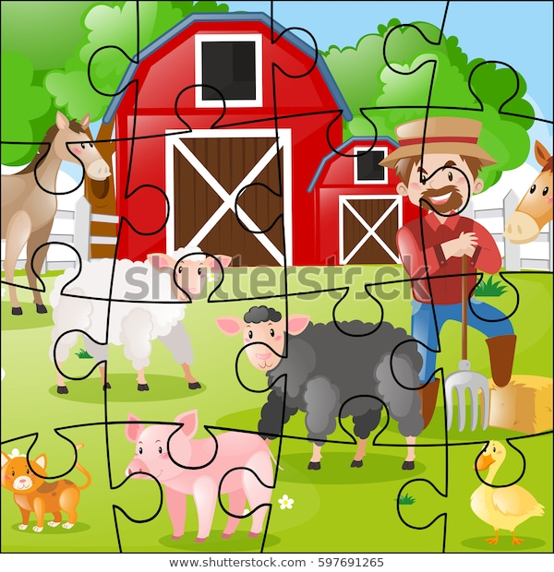

**Listening Task (WhatsApp Audio)**

**Script:**

Hi mom! How is dad? I’m so excited of being on the farm. My cousin Ericka is always busy, but she takes me everywhere she goes, and I help her to do her chores. We wake up early in the morning to milk the cows. I love Anabelle, the cow, and she gives a lot of milk. Then, we go to pick up the eggs. Aunt Lilly has many hens and chickens. They are so noisy! After breakfast, Ericka and I go to the field and help the uncle to plant seeds and pick up fruit. That’s my favorite part of the day because I get to eat delicious apples. Later in the afternoon, we water the plants and finally we have dinner and go to bed early.

I miss you, but I’m having so much fun here that I’m going to stay a little bit longer, if you don’t mind. Love ya! Kiss!

|  |
| --- |
| **What does Karla do at her cousin’s farm?**  **Instructions:**  Listen to the audio and circle all the activities Karla does during the day while being at her cousin’s farm. |
| Proudly Stock Photos, Stock Images and Vectors (Page 2) | StockfreshCurved Apple Images, Stock Photos & Vectors | Shutterstock  Ilustración De Los Niños Felices Para Ordeñar Una Vaca Fotos ...Imágenes, fotos de stock y vectores sobre Hen Picking the Food ...  Girl Planting Seeds ClipartJohn Deere Cartoon Tractor Free Clip Art Girl Driving - Girl ...Little Girl Watering Plants ClipartFeeding Farm Animals Clipart |

|  |
| --- |
| Bucket Drawing , cartoon milk pail transparent background PNG ...Seeds clipart 3 » Clipart Station  Library of shovels clipart library stock png files ▻▻▻ Clipart ...Cartoon Farmer Clipart Png  241,078 Basket Stock Vector Illustration And Royalty Free Basket ...  Transparent Pouring Water Clipart - Garden Watering Can Clipart ...  Wheelbarrow Clipart | Carretilla, Jardinería, Oficios |

|  |
| --- |
| Bucket Drawing , cartoon milk pail transparent background PNG ...Seeds clipart 3 » Clipart Station  Library of shovels clipart library stock png files ▻▻▻ Clipart ...Cartoon Farmer Clipart Png  241,078 Basket Stock Vector Illustration And Royalty Free Basket ...  Transparent Pouring Water Clipart - Garden Watering Can Clipart ...  Wheelbarrow Clipart | Carretilla, Jardinería, Oficios |

|  |
| --- |
| **C:\Users\Greivin\AppData\Local\Microsoft\Windows\INetCache\Content.MSO\E17335CE.tmpInstructions**: Write complete sentences using the words given. **Work in pairs.**  Farmer/plant trees:  Example:  *The farmer plants trees.*  C:\Users\Greivin\AppData\Local\Microsoft\Windows\INetCache\Content.MSO\838DF30C.tmp  Children/grow vegetables: \_\_\_\_\_\_\_\_\_\_\_\_\_\_\_\_\_\_\_\_\_\_\_\_\_\_\_\_\_\_\_\_\_\_\_\_\_\_\_\_\_\_\_\_\_\_\_\_\_\_\_\_\_\_\_\_.  C:\Users\Greivin\AppData\Local\Microsoft\Windows\INetCache\Content.MSO\1AC728FA.tmp  My aunt and uncle/ work/ garden \_\_\_\_\_\_\_\_\_\_\_\_\_\_\_\_\_\_\_\_\_\_\_\_\_\_\_\_\_\_\_\_\_\_\_\_\_\_\_\_\_\_\_\_\_\_\_\_\_\_\_\_\_\_\_.  C:\Users\Greivin\AppData\Local\Microsoft\Windows\INetCache\Content.MSO\ACFD4B18.tmp  My sister/ milk cow:  \_\_\_\_\_\_\_\_\_\_\_\_\_\_\_\_\_\_\_\_\_\_\_\_\_\_\_\_\_\_\_\_\_\_\_\_\_\_\_\_\_\_\_\_\_\_\_\_\_\_\_\_\_\_\_.  C:\Users\Greivin\AppData\Local\Microsoft\Windows\INetCache\Content.MSO\CF8C98E6.tmp  My father/harvest vegetables:  \_\_\_\_\_\_\_\_\_\_\_\_\_\_\_\_\_\_\_\_\_\_\_\_\_\_\_\_\_\_\_\_\_\_\_\_\_\_\_\_\_\_\_\_\_\_\_\_\_\_\_\_\_\_\_\_.  C:\Users\Greivin\AppData\Local\Microsoft\Windows\INetCache\Content.MSO\A72CFDE4.tmp  My sister/feed pig:  \_\_\_\_\_\_\_\_\_\_\_\_\_\_\_\_\_\_\_\_\_\_\_\_\_\_\_\_\_\_\_\_\_\_\_\_\_\_\_\_\_\_\_\_\_\_\_\_\_\_\_\_\_\_\_\_\_\_. |

|  |
| --- |
| **Instructions:**  Use the phrases in the box to complete the sentences. |
| **My uncle`s farm**  My uncle Carlos has a wonderful farm in Cartago. A lot of people work there. My  aunt Ana wakes up early, and she \_\_\_\_\_\_\_\_\_\_\_\_\_\_\_\_\_\_\_\_\_\_\_\_\_\_\_\_\_\_. My  Vector Cartoon Of Woman Milking Cow Royalty Free Cliparts, Vectors ...  cousin Vini \_\_\_\_\_\_\_\_\_\_\_\_\_\_\_\_\_\_\_\_\_\_\_\_ every day. In this moment, my uncle is  Boy give seed to chicken eat vector image on | Động vật, Giáo dục  digging the land. He \_\_\_\_\_\_\_\_\_\_\_\_\_\_\_\_\_\_\_\_\_\_\_\_\_\_\_\_\_\_\_\_\_\_\_ to sell at the  Grow Vegetables Clipart  farmer’s market. My granny, María also helps on the farm. She \_\_\_\_\_\_\_\_\_\_\_\_\_\_\_  Granny Garden Stock Illustrations – 179 Granny Garden Stock ...  \_\_\_\_\_\_\_\_\_\_\_\_\_\_\_\_\_\_. I love my uncle’s farm.   |  | | --- | | feeds the hens / waters the vegetables / grows vegetables /milks the cow | |

|  |  |  |
| --- | --- | --- |
| **English Grapheme** | **Picture** | **Vocabulary** |
| a |  | salt |  | C:\Users\Greivin\AppData\Local\Microsoft\Windows\INetCache\Content.MSO\E2164CC9.tmp |
|  | apple | C:\Users\Greivin\AppData\Local\Microsoft\Windows\INetCache\Content.MSO\493B9887.tmp |
|  | waiter | C:\Users\Greivin\AppData\Local\Microsoft\Windows\INetCache\Content.MSO\40197951.tmp |
| h |  | house | C:\Users\Greivin\AppData\Local\Microsoft\Windows\INetCache\Content.MSO\43268B35.tmp |
|  | cashier | C:\Users\Greivin\AppData\Local\Microsoft\Windows\INetCache\Content.MSO\1F6252BF.tmp |
| i |  | milk | Waiter Clipart |
|  | pineapple | C:\Users\Greivin\AppData\Local\Microsoft\Windows\INetCache\Content.MSO\41C99B2D.tmp |
| j |  | jar | C:\Users\Greivin\AppData\Local\Microsoft\Windows\INetCache\Content.MSO\4097454F.tmp |
|  | juice | C:\Users\Greivin\AppData\Local\Microsoft\Windows\INetCache\Content.MSO\DECD02C3.tmp |

|  |  |
| --- | --- |
| Objects - Pail of milk - 01 - Non-country specific | IYCF Image Bank | Seeds clipart 3 » Clipart Station |
| 241,078 Basket Stock Vector Illustration And Royalty Free Basket ... | Transparent Pouring Water Clipart - Garden Watering Can Clipart ... |
|  | Library of shovels clipart library stock png files ▻▻▻ Clipart ... |

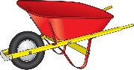



|  |  |
| --- | --- |
| Curved Apple Images, Stock Photos & Vectors | Shutterstock | Vectores, imágenes y arte vectorial de stock sobre Farmer Driving ... |
| Farmer Watering Plants Clipart | Farmer Feed Cow Stock Vector (Royalty Free) 248386069 |

|  |  |
| --- | --- |
| Digging Soil Clipart | Chicken farmer with eggs - Download Free Vectors, Clipart Graphics ... |
| Ilustración De Los Niños Felices Para Ordeñar Una Vaca Fotos ... | Diseño de vectores de planta de maíz. |

|  |  |
| --- | --- |
| Fall Harvest Farmer Couple, Green Vegetables, Food Basket ... | Ilustraciones, imágenes y vectores de stock sobre Farmer Plant ... |
| Print Look after animals flashcards | Easy Notecards |  |

|  |  |  |  |  |  |  |  |  |  |
| --- | --- | --- | --- | --- | --- | --- | --- | --- | --- |
| **Term: Second** | | **Level: Fourth** | | | **Unit: 3** | | | **Week:2** | |
| **Domain: Transactional** | | **Scenario: Farm to table** | | | | **Theme: Let’s go to the farmer’s market** | | | |
| **Enduring Understanding**: Fertile land and farming are necessary to have fresh food on the table and provide us with the ingredients for a good meal | | | | | | | | | |
| Essential Question: What does it take to have fresh food on our table? | | | | | | | | | |
| |  | | --- | | **Dimensions** | | **1.** **Ways of thinking ( X  )** | | **2. Ways of living in the world  ( )** | | **3. Ways of relating with others  ( X )** | | **4. Tools for integrating with the world  ( X )** | | | | | | | | | | |
| **Learn to Know** | | | | **Learn to Do** | | | | **Learn to Be and Live in Community** | |
| **Grammar &Sentence Frames**  Present simple in sentences with adjectives modifying nouns (quantity, size, shape, color)   * I want three big oranges. * I need three big carrots. * I want three cheeseburgers and a small size order of French fries.   Articles with Count and non-count nouns   * An apple/ apples * A horse/ horses * Milk / some milk * Salt / some salt   **Phonemic Awareness**  Reading contractions   * Doesn’t, don’t, didn’t, aren’t   **Vocabulary**  2. Let´s go to the farmers’ market  Selling:   * stores, markets,   Costa Rican crops   * bananas, oranges, pineapples, mangoes, vegetables, corn, * palm oil, chocolate, ornamental plants   Meats   * Pork, poultry, beef, seafood | | | | **Function**   * Describing things and places   **Discourse Markers**  Linkers: Sequential - past tense  First, then, after that, finally | | | | **Psycho-social**   * Shows willingness to work cooperatively   **Sociocultural**   * Polite forms to greet, say good-bye and address people in different settings/ farm/ friends/farmer’s market, restaurant   **Idioms/phrases**  Green thumbs (Good at gardening) My dad was born with green thumbs. He´s great with plants. | |
| **Assessment Strategies & indicators of learning** | **Goals** | | | **Pedagogical mediation/Didactic Sequence** | | | | | **Time** |
|  |  | | | **Pre-teaching**  **Routine:** Checking attendance, checking in with Ls, T posts the Essential Question on the board, Can Do’s, and class agenda, etc.  **Warm up**  The teacher sticks the picture of a Farmer’s Market on the board and asks learners if they remember what the picture represents. Then, the teacher explains that in today’s class, they are going to read the poem “At the farmer’s market” by Buffy Silverman. The learners listen to the teacher reading the poem, and they join the reading.  Thinking about fresh veggies and tasty fruits? Share "At the Farmer's Market" by Buffy Silverman (in English or Spanish) from THE POETRY FRIDAY ANTHOLOGY® FOR CELEBRATIONS edited by Sylvia Vardell and Janet Wong (Pomelo Books, 2015)  **Activation of prior knowledge**  Learners watch the video “At Mega Farmer’s Market in Costa Rica” (**0:58 – 9:34** min)  <https://www.youtube.com/watch?v=nCW_Tce9nCo>. As learners watch the video, they are asked to recall all the kinds of food they see. Then, they brainstorm those words as a whole class while teacher writes them down on the board.  **Modeling**  Farmer market isometric icons set of counters boxes casks with ...The teacher explains that at the Farmer’s Market people can find fresh produce such as fruit, vegetables, greens, dairy products, seafood and meat. The teacher presents some flashcards to illustrate the kinds of food found at the farmer’s market. The pictures are in different stands all over the board (simulating a farmer’s market). The teacher shows the different kids of food and invites learners to remember the name of those products. As learners remember the vocabulary, the teacher writes the name of the product next to the corresponding picture.  Indian Vegetable Vendor Clipart  Ilustración de Venta De Productos Lácteos En El Mercado Local De ...  USU Extension and Food Sense Presented the Huntington Farmers ...  Greengrocery.  Carnicero Shop del vector ilustración del vector. Ilustración de ...  The teacher sets up a table with different products found at the farmer’s market, and then he/she explains the difference between countable and uncountable nouns:  For example, *“I can count the apples: one apple, two apples, three apples, etc. I can count the oranges: I have three big oranges. But I can’t count milk. I can’t say: “I need three milks. I have to say: “I need some milk, or I need three bottles of milk.*  When I go to the farmer’s market, I can buy products, and to do so I can say: “I **want**…… (four green mangoes**), I need** three pineapples. **I need some** cheese.  The teacher writes two headings on the board: **Countable and Noncountable** and gives each pair of students a set of countable and uncountable noun cards. The students shuffle the cards and place them face down in a pile on the table. Students then take it in turns to turn over a noun card and place it under a countable or uncountable noun heading. When the students have finished, the teacher elicits the correct answers from the class. Then, the whole class is asked to make meaningful sentences using “**I want…. , I need…**”  Countable and Uncountable Nouns | Free Lessons And Worksheets  **Clarifying**  The teacher spreads the cards used in the modeling activity on the floor and divides the class into two groups. One group is asked to look for the cards representing food we can count, and the other group looks for food we cannot count. The learners stick the cards on the board in the corresponding column. Feedback is provided by peers.  Learners get a worksheet in which they must classify countable and noncountable kinds of food into the corresponding column. Learners compare their answers in pairs. Then, those images are used to practice saying: “**I want… I need…”**   |  |  | | --- | --- | | **Instructions:**  These are foods that farmers sell at the Farmer’s Market. Some of them are countable and some are uncountable. Classify them into the corresponding column. | | | **Countable**  We can count… (apples)   * An apple * Two apples | **Uncountable**  We cannot count… (rice)   * Some rice | |  |  | | Bag Of Sugar Clipart  C:\Users\Gabriela Castillo\AppData\Local\Microsoft\Windows\INetCache\Content.MSO\DBDC69CE.tmpTomato Free vector in Adobe Illustrator ai ( .AI ), Encapsulated ...C:\Users\Gabriela Castillo\AppData\Local\Microsoft\Windows\INetCache\Content.MSO\EFE4ECD1.tmpZanahoria clipart. Dibujos animados descargar gratis. | CreazillaOnion colored illustration #onion | Arte e decoração, Pinturas, ArteC:\Users\Gabriela Castillo\AppData\Local\Microsoft\Windows\INetCache\Content.MSO\759905A5.tmpC:\Users\Gabriela Castillo\AppData\Local\Microsoft\Windows\INetCache\Content.MSO\E3DB823F.tmp  Simple Milk Pack and Glass Clipart Free PNG Image｜Illustoon  Transparent Flounder Clipart - Meat Images Clip Art, HD Png ... | | | | | | |  |
| **L.2.** Recognizes the most important points in a straightforward talk or presentation.  **Indicators of learning**  Recognizes vocabulary related to food at the farmer’s market in a straightforward talk | **L.2.** understand the most important points in a straightforward talk or presentation, accompanied with drawings and/or diagrams, provided there was some previous familiarity with the topic. | | | **Oral Comprehension**  **Pre-task**  The teacher shares the goal of the lesson  Learners review the vocabulary and expressions by playing **Paradise Bound** ( Idea taken from<https://busyteacher.org/22370-count-noncount-nouns-11-fun-games.html>) The teacher put picture cards on the board ( countable and noncountable food) Learners are asked : **What food would a person need if they were stranded on a desert island?** The class is divided into groups of about four or five. Each group must decide on what food they will need to survive on their island. They can only bring ten items (though they can choose the quantity of the item that they want) and at least four of those items must be noncount nouns. Each group discusses it and then presents their final list to the class after everyone is finished.  Learners are encouraged to select the items using the expressions **“I want… I need…”**  Also, the teacher explains that for uncountable items we can use some words to make them countable:  I want some milk---- I want two **bottles** of milk.  I need some cheese--- I need two **kilos** of cheese.  I want some honey--- I want a **jar** of honey.  **Task-rehearsal**  The teacher sets up the pictures used in the previous activities on tables in front of the classroom and asks some volunteers to act if they were the farmers selling the products. Then, the teacher takes out some groceries bags and pretends to go shopping to the farmer’s market. Learners sit in pairs. They listen to the teacher and write a list of all the things he/she buys at the market  The teacher says, for example, “*It’s Thursday, and it’s my day to go to the farmer’s market. I need some vegetables and fruits to buy*.” The teacher walks around the classroom and stops to see the pictures: *“Mmm! This pineapple looks delicious. I want three pineapples, please, and 10 oranges. Lettuce? No, I think I don’t need any lettuce, but I need five cucumbers please. Wow, there is cheese here. I want some. Please, a kilo of cheese, and some milk to, two bottles please…”*  Then, the learners compare their answers with the rest of the group.  **Task completion**  Learners listen to the text “**Shopping at the Farmer’s Market**”. As learners listen, they check the products from the shopping list Erin and Steve bought. In pairs, learners compare their answers and then they share with the whole group.  The audio is played twice, or more, if necessary. The teacher monitors learner’s performance.   |  | | --- | | **Instructions:**  Erin and Steve are at the Farmer’s Market. What did they buy? Check the food they bought. | | USU Extension and Food Sense Presented the Huntington Farmers ... | | **LET’S GO SHOPPING** | | * **Cucumbers** | | * **Strawberries** | | * Clip Art: Spinach Color I abcteach.com | abcteach**Corn** | | * Zanahoria clipart. Dibujos animados descargar gratis. | Creazilla**Bell Pepper** | | * **Tomatoes** | | * **Spinach** | | * **Cabbage** | | * Clipart broccoli » Clipart Station**Apples** | | * Free Tomato Cliparts, Download Free Clip Art, Free Clip Art on ...**Carrots** | | * **Broccoli** | | * **Pears** | | * Clip Art: Basic Words: Eggs Color Unlabeled I abcteach.com | abcteach**Eggs** | | * C:\Users\Gabriela Castillo\AppData\Local\Microsoft\Windows\INetCache\Content.MSO\EFE4ECD1.tmp**Onion** | | * **Fish** | | * **Milk** | | * **Meat** | | * Vanilla Yogurt Clipart**Cheese** | | * Mackerel Fish Clipart Free PNG Image｜Illustoon**Yogurt** | | * **Honey** |     **[Script:](http://Script: Adapted from www.lingoda.com)** [Adapted from www.lingoda.com](http://Script: Adapted from www.lingoda.com)  It’s a sunny Sunday afternoon today and Erin is walking through a farmer’s market with Steve. They are shopping for ingredients so they can cook a nice dinner later. There are many people at the market. Erin sees a man who is selling vegetables. They look fresh and delicious. “We should get some vegetables so we can make a salad,” says Erin. “Good idea, Erin. There are lots of vegetables here and they all look so good!”  They pick out some cucumbers, tomatoes, onions, and lettuce. They pay for the vegetables and look around the market. They buy two apples, three pears, some meat and a few other things for their dinner, too. “I can make the salad tonight,” says Erin, but we don’t have any cheese at home.” Look, there is cheese.” Says Steve, and they get a kilo of cheese and two bottles of milk. They walk home happily after their shopping at the farmer’s market.  **Task assessment**  Students play the game “**At the farmer’s market**”. The teacher gives students recycling paper. In pairs, learners role- play a short conversations at the market. One student is the customer and asks for one product, the other student has to draw the product his/her friend wants. For example,  **Student A**. I need three big oranges.  **Student B** Here you have (The student B has to draw the product and give it to the student A)  Students take turns to ask and draw.  Learners work on peer assessment their achievement of the goal  **Achieved  Not yet** | | | | |  |
| **SP.2.** Describes basic aspects of their day-to-day life.  Recalls vocabulary related to farm activities.  Uses complete sentences patterns.  Describes farm activities briefly. | **SP.2.** describe basic aspects of their day-to-day life, such as favorite foods and daily activities. | | | **Oral Production**  **Pre-task**  The teacher shares the goal of thelesson  The teacher tells the class that they are going to go on a field trip to a farm, but first they need to review a little bit about the farm life before going to visit. The class is divided into groups of four, and each group gets poster paper and markers. Each learner in their group draws one characteristic of a farm: crops, animals, farmer doing different activities, etc. Then, each group adds extra features to their farm.  Using the poster the groups drew, the teacher describes characteristics of the farm and recalls what farmers do on the farm. The teacher asks questions to the group to encourage learners to use the expressions and vocabulary from previous lessons.  “*This is a farm. On the farm, there are cows, hens, and pigs. The farmer is feeding the animals and collecting eggs. The lady is planting seeds. The boys are picking up fruit.*  Teacher emphasizes on describing what the farmer is doing: **planting, digging out, collecting eggs, picking up fruit, etc.**  **Task Rehearsal**  The teacher chooses one the posters the groups drew and asks learners to say as many things they can say about the farm they see. Learners are encouraged to use expressions such as “There is/are… at the farm. The farmer is …..  The teacher points at a specific image on the poster and asks learners to describe what they see: **“The farmer is driving a tractor.” The farmer is feeding the animals.”**  **Task completion**  The teacher explains that the class is going on a field trip to each of the farms they drew. To do so, groups display their posters all over the classroom. Half of the class will be the ones describing the posters, and the other half will be the visitors. Then, the groups switch roles.  The teacher monitors learners’ performance and encourages all learners to describe their farm using complete sentence patterns.  **Task assessment**  The teacher randomly points at different images of farmers on the posters and asks learners what the farmer is doing:  *Yes! The farmer is feeding the animals. He feeds the animals every morning.”*  *Is the farmer milking the cows? Exactly! He milks the cows every day.*  Learners work on self and peer assessment. Whole class pays attention to the presentation and assesses their achievement of the goal by giving feedback to their peers. The teacher monitors the feedback.  **/var/folders/4s/0g_lyff907n4m_ksnpb59sph0000gn/T/com.microsoft.Word/Content.MSO/96AF8D06.tmp**Yes! /var/folders/4s/0g_lyff907n4m_ksnpb59sph0000gn/T/com.microsoft.Word/Content.MSO/F3FBA704.tmp Sort of Resultado de imagen para sad emoticonNo.Help! | | | | |  |
| **W.2.** Composes short sentences and notes for describing activities at the farm and food preferences.  Writes short complete sentences about activities at the farm. | **W.2.** compose short sentences and notes for describing activities at the farm and food preferences. | | | **Written Production**  **Pre-task**  The teacher shares the goal of the lesson.  Learners review the vocabulary and target structure by playing “Chalkboard Pictionary.” The class is divided into two teams. The teacher creates a small column for each team on one side of the board. One person from Team A comes up to the front and draws a card with the picture of activities the farmer does at the farm. The learners must convey the sentence to his/her team using only drawings. Students cannot use words, symbols or hand gestures. Limit the time to two minutes maximum. Each correct sentence is a point and the team to get more points is the winning team.  **Task-Rehearsal**  Learners work on a ‘**Sentence Building’** activity. A group of students is called to the front. The teacher gives each one a card with a word. The group is asked to put those words in order to create a logical sentence.   |  |  |  |  |  | | --- | --- | --- | --- | --- | | **the** | **milks** | **farmer** | **cows** | **the** |   The activity continues with another group of students and a different sentence.  **Task completion**  Learners use the images provided to complete the sentences. Then, they put all the sentences together into one single text. The teacher monitors learners’ performance of the task.   |  |  |  |  |  | | --- | --- | --- | --- | --- | | **At the Farm** | | | | | | **At the farm, there are/is…** | Vacas Ilustraciones Stock, Vectores, Y Clipart – (3,986 ... | Pigs Clipart Stock Illustrations – 387 Pigs Clipart Stock ... | Chicken House Chicken Coop Clipart | Horse and farm - Download Free Vectors, Clipart Graphics & Vector Art | | The farmer is always busy. He… | Cow Giving Milk Clipart | A Young Farmer In A Garden With A Carrot. Stock Illustration ... | Farmer Watering Plants Clipart | Imágenes, fotos de stock y vectores sobre Feed - Farm - Food ... | | **At the farm, the farmer grows\_\_\_\_\_, \_\_\_\_\_, and \_\_\_.** | Vegetable In Basket Clipart | | Fruit Basket coloring page, printable Fruit Basket | | | Put your text together here.  At the Farm  \_\_\_\_\_\_\_\_\_\_\_\_\_\_\_\_\_\_\_\_\_\_\_\_\_\_\_\_\_\_\_\_\_\_\_\_\_\_\_\_\_\_\_\_\_\_\_\_\_\_\_\_\_\_\_\_\_\_\_\_\_\_\_\_\_\_\_\_\_\_\_\_\_\_\_\_\_\_\_\_\_\_\_\_\_\_\_\_\_\_\_\_\_\_\_\_\_\_\_\_\_\_\_\_\_\_\_\_\_\_\_\_\_\_\_\_\_\_\_\_\_\_\_\_\_\_\_\_\_\_\_\_\_\_\_\_\_\_\_\_\_\_\_\_\_\_\_\_\_\_\_\_\_\_\_\_\_\_\_\_\_\_\_\_\_\_\_\_\_\_\_\_\_\_\_\_\_\_\_\_\_\_\_\_\_\_\_\_\_\_\_\_\_\_\_\_\_\_\_\_\_\_\_\_\_\_\_\_\_\_\_\_\_\_\_\_\_\_\_\_\_\_\_\_\_\_\_\_\_\_\_\_\_\_\_\_\_\_\_\_\_\_\_\_\_\_\_\_\_\_\_\_\_\_\_\_\_\_\_\_\_\_\_\_\_\_\_\_\_\_\_\_\_\_\_\_\_\_\_\_\_\_\_\_\_\_\_\_\_\_\_\_\_\_\_\_\_\_\_\_\_\_\_\_\_\_\_\_\_\_\_\_\_\_\_\_\_\_\_\_\_\_\_\_\_\_\_\_\_ | | | | |   **Task assessment**  In pairs, the learners practice reading the sentences they wrote and peer-correct each other.  The group assesses their performance, using the ‘**Corners**’ technique. Each corner in the classroom represents a different answer. Learners go to the corner that best represents how they feel with their achievement of the task.  **Corner 1**: I’m stuck! Please, help  **Corner 2:** I understand most of it, but I need more practice.  **Corner 3.** On my way! I can continue my own.  **Corner 4**: Got it! I can help others. | | | | |  |
| **R.PA.1.** Reads words and sentences blending English graphemes and phonemes.  Reads contractions  (don’t, doesn’t, didn’t, aren’t) within sentences, correctly. | **R.PA.1.** decode English graphemes and phonemes using knowledge of word parts, syllabification and phonemic awareness. | | | **Written Comprehension**  **Phonemic Awareness**  **Pre-task**  The teacher shares the goal of thelesson  The teacher uses a power point with the contractions **don’t, doesn’t, didn’t and aren’t**. First the teacher pronounces them. Then, in the same power point the teacher uses them in long sentences.  Resultado de imagen para verb to beHow to use do, does, did, don't, doesn't, didn't  **(PPT available in the materials for the unit)**  **Sample sentences**  I **don’t** need oranges  My mother **doesn’t** want bananas  The apples **aren`t** big  I **didn`t** buy the palm oil  **Task-rehearsal**  Students unscramble a list of words with the contractions studied and pronounce them in front of the class. Use the vocabulary from the ppt.  **Task completion**  Students work on a worksheet and the ppt in the link provided, in which the teacher reads a text and students have to fill in the blanks with don’t, didn’t, doesn’t and aren’t    **PPT: What do you like to eat?**  <https://www.liveworksheets.com/worksheets/en/English_as_a_Second_Language_(ESL)/Likes_and_dislikes/Likes_and_dislikes_vn405gi>  **Task assessment**  The teacher says affirmative sentences and learners have to change them to negative using the contractions previously studied. They have to express them orally. | | | | |  |
| **Integrated Mini-Project** | | | | | | | | | **Time** |
| * **Planning:**The class is divided into groups of three. Learners are told they are going to prepare a Cooking Show Skit to show how to make a simple recipe. The groups find a recipe for a meal of their choice. * **Creating:** Learners write the ingredients and quantities they need, the utensils, and the steps (in a sequential order) to prepare the recipe. * **Rehearsing:** Learners rehearse their Cooking Show. * **Participating:** Learners present their Cooking Show to the class. The teacher can record each presentation in a video (if parents agree) and the videos can be presented to the whole class. | | | | | | | | |  |
| **Reflective Teaching** | | | | | | | | | |
| What worked well | | | What didn’t work well | | | | How to improve | | |
| **Enduring Understanding Reflection** | | | | | | | | | |
|  | | | | | | | | | |

|  |  |  |  |
| --- | --- | --- | --- |
| **Learner Self-Assessment** | | | |
| ***I can…*** | ***Yes*** | ***Sort of*** | ***No. Help!*** |
| Recognize vocabulary related to food at the farmer’s market in a straightforward talk |  |  |  |
| Describe farm activities, briefly. |  |  |  |
| Write short complete sentences about activities at the farm |  |  |  |
| Reads contractions (don’t, doesn’t, didn’t, aren’t) correctly. |  |  |  |

|  |
| --- |
| Thinking about fresh veggies and tasty fruits? Share "At the Farmer's Market" by Buffy Silverman (in English or Spanish) from THE POETRY FRIDAY ANTHOLOGY® FOR CELEBRATIONS edited by Sylvia Vardell and Janet Wong (Pomelo Books, 2015) |
| Indian Vegetable Vendor Clipart |

|  |
| --- |
| Farmer market isometric icons set of counters boxes casks with ... |
| Ilustración de Venta De Productos Lácteos En El Mercado Local De ... |

|  |
| --- |
| Greengrocery. |
| Carnicero Shop del vector ilustración del vector. Ilustración de ... |

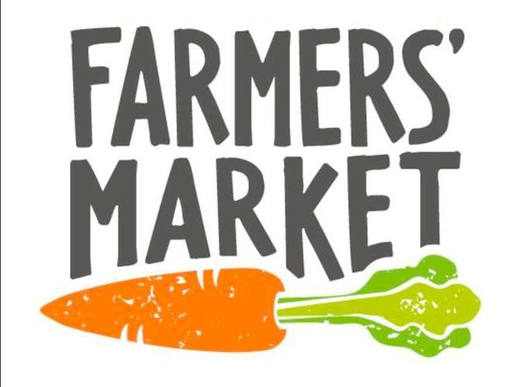

**Countable and Uncountable Cards**

|  |  |  |
| --- | --- | --- |
| Simple Milk Pack and Glass Clipart Free PNG Image｜Illustoon |  | C:\Users\Gabriela Castillo\AppData\Local\Microsoft\Windows\INetCache\Content.MSO\3BC929AC.tmp |
| Tomato Free vector in Adobe Illustrator ai ( .AI ), Encapsulated ... | Clipart rice 12 » Clipart Station |
| Cucumber Clipart - Pickled Cucumber Transparent PNG - 1280x720 ... | Vanilla Yogurt Clipart |
| Clip Art: Basic Words: Eggs Color Unlabeled I abcteach.com | abcteach | C:\Users\Gabriela Castillo\AppData\Local\Microsoft\Windows\INetCache\Content.MSO\D6FE94CF.tmp |

|  |  |  |
| --- | --- | --- |
| Cartoon Jar Of Honey Royalty Free Cliparts, Vectors, And Stock ... |  | C:\Users\Gabriela Castillo\AppData\Local\Microsoft\Windows\INetCache\Content.MSO\EFE4ECD1.tmp |
| Bananas+clipart: Imágenes, fotos de stock y vectores | Shutterstock | Free Flour Cliparts, Download Free Clip Art, Free Clip Art on ... |
| Library of a head of lettuce picture free png files ▻▻▻ Clipart ... | Transparent Flounder Clipart - Meat Images Clip Art, HD Png ... |
| C:\Users\Gabriela Castillo\AppData\Local\Microsoft\Windows\INetCache\Content.MSO\771E7A43.tmp | Onion colored illustration #onion | Arte e decoração, Pinturas, Arte |

|  |  |
| --- | --- |
| **Instructions:**  These are kinds of food that farmers sell at the Farmer’s Market. Some of them are countable and some are uncountable. Classify them into the corresponding column. | |
| **Countable**  We can count… (apples)   * An apple * Two apples | **Uncountable**  We cannot count… (rice)   * Some rice |
|  |  |
| C:\Users\Gabriela Castillo\AppData\Local\Microsoft\Windows\INetCache\Content.MSO\E3DB823F.tmp  Bag Of Sugar ClipartZanahoria clipart. Dibujos animados descargar gratis. | CreazillaOnion colored illustration #onion | Arte e decoração, Pinturas, ArteC:\Users\Gabriela Castillo\AppData\Local\Microsoft\Windows\INetCache\Content.MSO\759905A5.tmp  Simple Milk Pack and Glass Clipart Free PNG Image｜IllustoonC:\Users\Gabriela Castillo\AppData\Local\Microsoft\Windows\INetCache\Content.MSO\EFE4ECD1.tmpTomato Free vector in Adobe Illustrator ai ( .AI ), Encapsulated ...C:\Users\Gabriela Castillo\AppData\Local\Microsoft\Windows\INetCache\Content.MSO\DBDC69CE.tmp  Transparent Flounder Clipart - Meat Images Clip Art, HD Png ... | |

|  |
| --- |
| **Instructions:**  Erin and Steve are at the Farmer’s Market. What did they buy? Check the food they bought. |
| USU Extension and Food Sense Presented the Huntington Farmers ... |
| **LET’S GO SHOPPING** |
| * **Cucumbers** |
| * **Strawberries** |
| * Clip Art: Spinach Color I abcteach.com | abcteachZanahoria clipart. Dibujos animados descargar gratis. | Creazilla**Corn** |
| * **Bell Pepper** |
| * **Tomatoes** |
| * Free Tomato Cliparts, Download Free Clip Art, Free Clip Art on ...**Spinach** |
| * **Cabbage** |
| * Clipart broccoli » Clipart Station**Apples** |
| * **Carrots** |
| * **Broccoli** |
| * **Pears** |
| * Clip Art: Basic Words: Eggs Color Unlabeled I abcteach.com | abcteach**Eggs** |
| * C:\Users\Gabriela Castillo\AppData\Local\Microsoft\Windows\INetCache\Content.MSO\EFE4ECD1.tmp**Onion** |
| * **Fish** |
| * **Milk** |
| * **Meat** |
| * Vanilla Yogurt Clipart**Cheese** |
| * Mackerel Fish Clipart Free PNG Image｜Illustoon**Yogurt** |
| * **Honey** |

|  |  |  |  |  |
| --- | --- | --- | --- | --- |
| **At the Farm** | | | | |
| **At the farm, there are/is…** | Vacas Ilustraciones Stock, Vectores, Y Clipart – (3,986 ... | Pigs Clipart Stock Illustrations – 387 Pigs Clipart Stock ... | Chicken House Chicken Coop Clipart | Horse and farm - Download Free Vectors, Clipart Graphics & Vector Art |
| The farmer is always busy.  He… | Cow Giving Milk Clipart | A Young Farmer In A Garden With A Carrot. Stock Illustration ... | Farmer Watering Plants Clipart | Imágenes, fotos de stock y vectores sobre Feed - Farm - Food ... |
| **At the farm, the farmer grows**  **\_\_\_\_\_, \_\_\_\_\_, and \_\_\_.** | Vegetable In Basket Clipart | | Fruit Basket coloring page, printable Fruit Basket | |
| Put your text together here. At the Farm  \_\_\_\_\_\_\_\_\_\_\_\_\_\_\_\_\_\_\_\_\_\_\_\_\_\_\_\_\_\_\_\_\_\_\_\_\_\_\_\_\_\_\_\_\_\_\_\_\_\_\_\_\_\_\_\_\_\_\_\_\_\_\_\_\_\_\_\_\_\_\_\_\_\_\_\_\_\_\_\_\_\_\_\_\_\_\_\_\_\_\_\_\_\_\_\_\_\_\_\_\_\_\_\_\_\_\_\_\_\_\_\_\_\_\_\_\_\_\_\_\_\_\_\_\_\_\_\_\_\_\_\_\_\_\_\_\_\_\_\_\_\_\_\_\_\_\_\_\_\_\_\_\_\_\_\_\_\_\_\_\_\_\_\_\_\_\_\_\_\_\_\_\_\_\_\_\_\_\_\_\_\_\_\_\_\_\_\_\_\_\_\_\_\_\_\_\_\_\_\_\_\_\_\_\_\_\_\_\_\_\_\_\_\_\_\_\_\_\_\_\_\_\_\_\_\_\_\_\_\_\_\_\_\_\_\_\_\_\_\_\_\_\_\_\_\_\_\_\_\_\_\_\_\_\_\_\_\_\_\_\_\_\_\_\_\_\_\_\_\_\_\_\_\_\_\_\_\_\_\_\_\_\_\_\_\_\_\_\_\_\_\_\_\_\_\_\_\_\_\_\_\_\_\_\_\_\_\_\_\_\_\_\_\_\_\_\_\_\_\_\_\_\_\_\_\_\_\_\_\_\_\_\_\_\_\_\_\_\_\_\_\_\_\_\_\_\_\_\_\_\_\_\_\_\_\_\_\_\_\_\_\_\_\_\_\_\_\_\_\_\_\_\_\_\_\_\_\_\_\_\_\_\_\_\_\_\_\_\_\_\_\_\_\_\_\_\_\_\_\_\_\_\_\_\_\_\_\_\_\_\_\_\_\_\_\_\_\_\_\_\_\_\_\_\_\_\_\_\_\_\_\_\_\_\_\_\_\_\_\_\_\_\_\_\_\_\_\_\_\_\_\_\_\_\_\_\_\_\_\_\_\_\_\_\_\_\_\_\_\_\_\_\_\_\_\_\_\_\_\_  \_\_\_\_\_\_\_\_\_\_\_\_\_\_\_\_\_\_\_\_\_\_\_\_\_\_\_\_\_\_\_\_\_\_\_\_\_\_\_\_\_\_\_\_\_\_\_\_\_\_\_\_\_\_\_\_\_\_\_\_\_\_\_\_\_\_\_\_\_\_\_\_\_\_\_\_\_\_\_\_\_\_\_\_\_\_\_\_\_\_\_\_\_\_\_\_\_\_\_\_\_\_\_\_\_\_\_\_\_\_\_\_\_\_\_\_\_\_\_\_\_\_\_\_\_\_\_\_\_\_\_\_\_\_\_\_\_\_\_\_\_\_\_\_\_\_\_\_\_\_\_\_\_\_\_\_\_\_\_\_\_\_\_\_\_\_\_\_\_\_\_\_\_\_\_\_\_\_\_\_\_\_\_\_\_\_\_\_\_\_\_\_\_\_\_\_\_\_\_\_\_\_\_\_\_\_\_\_\_\_\_\_\_\_\_\_\_\_\_\_\_\_\_\_\_\_\_\_\_\_\_\_\_\_\_\_\_\_\_\_ | | | | |

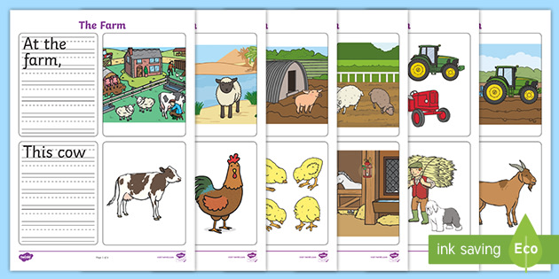

|  |  |  |  |  |  |  |  |  |  |
| --- | --- | --- | --- | --- | --- | --- | --- | --- | --- |
| **Term: Second** | | **Level: Fourth** | | | **Unit: 3** | | | **Week:3** | |
| **Domain: Transactional** | | | **Scenario:** Farm to Table | | | **Theme:** Let´s Make a Meal | | | |
| **Enduring Understanding**: Fertile land and farming are necessary to have fresh food on the table and provide us with the ingredients  for a good meal. | | | | | | | | | |
| **Essential Question:** What does it take to have fresh food on our table? | | | | | | | | | |
| |  | | --- | | **Dimensions** | | **1.** **Ways of thinking ( X )** | | **2. Ways of living in the world ( )** | | **3. Ways of relating with others ( X )** | | **4. Tools for integrating with the world ( X )** |   **New Citizenship:** | | | | | | | | | |
| **Learn to Know** | | | **Learn to Do** | | | **Learn to Be and Live in Community** | | | |
| **Grammar & Sentence Frames**  Count and non-count nouns with some, much and many   * I need some sugar. * How much sugar do you need? * I need to buy many bags of coffee.   Sequence adverbs with imperatives   * First, add an egg. * Second, pour the milk.   **Vocabulary**  3. Let´s make a meal  Verbs   * serve, pour * mix, combine, slice * Peel, chop, stir, * Add, cook   **Phonemic Awareness**  Consonant blends   * /pl/:planting, plowing * /st/:staying, stirring   /tr / transport, trailer | | | **Function**  Giving and  following directions  **Discourse Markers**  First, then, next, finally. | | | **Psycho-social**   * Develops cooperation practices to solve problems * Shows willingness to work cooperatively * Takes social responsibility for cultivating own * food * Values the work of farmers  Communicates * needs and desires effectively   **Socio-cultural**   * Cultural differences in terms of habits and routines between urban and rural settings * Polite forms to greet, say goodbye and address people in different settings/ farm/friends/farmer’s market, restaurant * Ways of expressing gratitude   **Idiom Phrase**  **To be starving (to be very hungry)** | | | |
| **Assessment Strategies & Evidences of learning**  **(Diagnostic, formative, summative)** | **Goals** | | **Pedagogical Mediation/ Didactic Sequence** | | | | | | **Time** |
|  |  | | **Pre-teaching**  **Warm up**  The teacher labels two boxes with the cards ‘Countable’ and ‘Uncountable’ (one card per box) and places them on the floor. The teacher brings pictures of countable and uncountable food to the class and hides them all over the classroom. The class is divided into two groups. A member of each group goes to the front, looks for the pictures, and locates them in the corresponding box. The rest of the group indicates where the pictures are hidden and helps their team member to locate each picture correctly in each box. The group which locates more pictures correctly in each box wins. The teacher provides feedback and reviews the meaning of countable and uncountable food.  **Activation of prior knowledge**  The class is divided into small groups. The teacher writes five sentences that elicit count and noncount nous and asks the groups to write a list of words that they would use to complete the blanks.  For example:   * I need three\_\_\_\_\_\_\_\_\_\_\_\_ (apples, bananas, eggs, etc.) * I need some \_\_\_\_\_\_\_\_\_\_\_\_ (milk, sugar, rice, honey, cheese) * I want a (an) \_\_\_\_\_\_\_\_\_\_\_\_\_ * I want some\_\_\_\_\_\_\_\_\_\_\_\_\_   The groups share their list with the rest of the class. Teacher writes the words on the board and provides feedback if necessary.  **Modeling**  The teacher writes ‘**How much’** and ‘**How many**’ on the board and invites learners to watch the following video: ‘How much? vs How many?<https://www.youtube.com/watch?v=QbeIFCTy9sU>  The teacher explains that ‘How much’ is used to ask question with uncountable food, and ‘How many” is used for countable food.  Teacher also explains that there are words that can help to make something uncountable into countable: cup, tablespoon, teaspoon, kilo, bar, bag ( use realia to introduce these words)  The teacher provides more examples for students and asks them to repeat after him/her:  How many eggs do you need? I need \_\_\_\_\_\_\_  How many oranges do you want? I want\_\_\_\_\_\_  How much sugar do you need? I need two cups of sugar.  How much honey do you need? I need a tablespoon of honey.  How much butter do you need? I need a bar of butter.  **Clarifying**  The teacher sticks the poster below on the board.  **How much.. do you need? How many... do you need?**    Teacher tells students to pretend they are at a grocery store. Using the pictures as clues, learners take turns to go to the front and ask for a product to the grocery seller (the teacher)  **Student**: I need some cheese.  **Teacher** ‘How much cheese do you need?  **Student:** I need a kilo of cheese.  Then, learners volunteer to take the role of the grocer and the customer. They practice asking the questions and answers. Teacher provides feedback. | | | | | |  |
| **R.1.**Recognizes much of what is written in short, simple texts.  **Indicators of learning**  Recognize the vocabulary related to coking actions.  Recognize the steps in a recipe. | **R.1.**Recognizes much of what is written in short, simple texts. | | **Written Comprehension**  **Pre-task**  The teacher shares the goal of the lesson. Learners watch the video ‘How to Make Easy Pancakes with 6yo Achilla | Cooking with Kids’ <https://www.youtube.com/watch?v=oEaIPmoQt-o>. Learners are asked to take notes on the ingredients used in the recipe. Then, they report back to the class. ***What do you need to make pancakes? We need…..***  **C:\Users\Gabriela Castillo\AppData\Local\Microsoft\Windows\INetCache\Content.MSO\B92F3BD3.tmp**Teacher sets up a table with the ingredients to make pancakes. Using realia and acting as he/she were a chef, the teacher introduces the following cooking verbs: serve, add, pour, mix, combine, cook, chop, stir, boil, peel, drain  Learners illustrate the cooking verbs in their notebook.  Nancy Kelbley (nancykelbley) on PinterestTest: Real Reading 2, Unit 5 Vocabulary | QuizletCooking Verbs  **Pour Combine**  **Mix**   **Stir**  Carácter De Chef Negro De Dibujos Animados Sosteniendo Una Pizza Y ...Cooking verbs  Pancakes - gluten-free, vegan, and delicious! • Valerie's Recipes  **Add Cook Serve**  **Task rehearsal**  Learners observe the teacher as he/she sticks the picture of the cooking verbs on the board and a set of cards with the corresponding verb. Volunteers take turns to match the cooking verb to its picture correctly. The rest of the class provides help.  The teacher writes some sentences on the board, and volunteers go to the front and mimic what the sentence says, for example: Pour the milk in the bowl. Add sugar.  Mix the ingredients. Cook the pancake.  The teacher provides feedback if necessary.  **Task completion**  Learners, individually, read the instructions to make pancakes and illustrate them with the corresponding picture. The teacher monitors learner’s performance.   |  |  |  | | --- | --- | --- | | **Pancake Recipe**  **Read the instructions and paste the pictures in the corresponding place.**  Inspiring Pancake Clip Art | Breakfast clipart, Food clipart, How ...**Ingredients** To make 4 pancakes:  1 cup of flour  1 teaspoon salt  2 tablespoons of sugar  2 teaspoons baking powder  1 cup of milk  1 egg | | | | 1. In a bowl mix the flour, sugar, salt and baking powder | 2. Add an egg into the bowl | 3. Pour the milk into the bowl. | |  |  |  | | 4. Mix all the ingredients together | 5. Cook mixture in a frying pan. | 6. Serve pancakes hot. | | Pancake Recipe Sheet Polish Translation (teacher made) | Free Pancakes Cliparts Candle, Download Free Clip Art, Free Clip ... |  | |  |  |  |   **Task Assessment**  The class is divided into groups of four. Each group is asked to draw the ingredients to make pancakes on pieces of paper. Each group goes to the front and explains the rest of the class how to make pancakes, using the ingredients they drew and the kitchen utensils the teacher brought (a bowl, a whisk) | | | | | |  |
| **SI.2** exchange information about everyday matters using simple vocabulary (e.g., favorite food, recipe  **Indicators of learning:**  Uses sequencing words correctly.  Uses the cooking actions correctly.  Describes how to prepare a simple recipe in a logical sequence. | **SI.2** exchange information about everyday matters using simple vocabulary (e.g., favorite food, recipe | | **Oral Production**  **Pre-task**  The teacher shares the goal of the lesson.  Learners listen to and sing the song “**Let’s make a sandwich/ Simple song for kids.”**  [https://www.youtube.com/watch?v=mK4O8hi30UAhttps://www.youtube.com/watch?v=mK4O8hi30UA](https://www.youtube.com/watch?v=mK4O8hi30UA)  The learners then tell the teacher what the ingredients for a sandwich are.  Next, the teacher sets a table with the ingredients (real or with pictures) to make a sandwich: two slices of bread, butter, a slice of cheese, a slice of tomato, and lettuce. Then, the teacher explains the procedures to make the sandwich.  **First**, get two slices of bread.  **Then**, **spread** butter on the bread.  **Nex**t, **put** the slice of cheese, ham, and tomato on the bread.  **After that**, put some lettuce on the bread.  **Finally**, cover the sandwich with the other slice of bread and enjoy it.  The teacher emphasizes on the use of sequencing words and the new verbs: spread and put.  **Task Rehearsal**  The teacher provides each learner with a handout with the ingredients to make a sandwich. Learners cut each ingredient. Using the song<https://www.youtube.com/watch?v=zds2CAkW1WI> , the teacher reviews the ingredients and then uses them to practice with the learners the steps to make a sandwich.  The teacher writes “My **Cooking Show”** on the board and gives aprons to two volunteers. They are asked to pretend they are presenting a cooking show where they are teaching the audience how to make a sandwich. Learners present their show. The teacher provides feedback when necessary. Two more volunteers go to the front and present their show.  **Task completion**  Learners are asked to draw two more ingredients they would like to add to the sandwich. Then, the class is divided into pairs. Learners use the new ingredients and the previous ones, to explain to their peer how to make a sandwich. The teacher monitors learners’ performance of the task.  **Task Assessment**  The teacher writes the steps to make a sandwich on the board (not in order). The class is divided into pairs. Each pair works together orally to put the steps in order, using the sequencing words: first, then, next, after that, finally. The teacher monitor learners’ performance.  Some volunteers go to the front and present the sequence of steps to make a sandwich to  the whole group.  **Post- Task**  The class watches the video and tries to recall the steps to make spaghetti. <https://www.youtube.com/watch?v=ErEy38dcCVg>  **Spaghetti in Tomato sauce | Spaghetti Recipe | Red Sauce spaghetti Pasta** The class is divided into groups of four. Together, and using the video as stimulus, the learners write the steps to make spaghetti and illustrate each step with drwaings. Then, they present the steps to the class orally. Teacher provides help when necessary. Learners can use the handout below as a stimulus to organize the steps of their recipe (optional). | | | | | |  |
| **R.PA.3.** decode English graphemes and phonemes using knowledge of word parts,  syllabification and phonemic awareness  **Indicators of learning**  Identifies beginning consonant blend **pl**.  Identifies beginning consonant blend **st**.  Identifies beginning consonant blend **tr**. | **R.PA.3.** decode English graphemes and phonemes using knowledge of word parts,  syllabification and phonemic awareness | | **Written Comprehension**  **Phonemic Awareness**  **Pre-task**  The teacher shares the goal of the lesson.  Teacher shows a video with consonant blends <https://www.youtube.com/watch?v=1xbhC37mkbk> **Meet the Phonics Blends – pl**<https://www.youtube.com/watch?v=4MqCXAzcIl4> **Meet the Phonics Blends - st**<https://www.youtube.com/watch?v=52UAYWlf-9c> **Meet the Phonics Blends - tr** The students will sit at their desks, attaining to the You Tube video/song about consonant blends. Students are encouraged to sing along and address any words they know along with the song.  The teacher introduces word with the consonant blends: **tr, st,** and **pl** and asks learners to repeat after him/her.   * **Tr**: tree, trunk, trophie, trash, truck, trampoline * **Pl**: planet, plane, plant, plug, plus, play * **St**: star, stir, stamp, stove, stop, stick   **Task-rehearsal**  Teacher ask learners to draw with some words with the blended words studied. They have to show their classmates and others try to guess which word it is.  The class is divided into groups of three. Each group will have an assigned consonant blend puzzle piece. Their task is to work together to pick up the other matching puzzle ending pieces. Learners must create 6 different words using their beginning blend puzzle piece. After learners have their 6 words, the teacher checks each word, and then the learners write the words on the board and the whole class reviews their pronunciation.    **Task completion**  Learners, individually, work the worksheet below. The teacher monitors learners’ performance.   |  |  |  |  | | --- | --- | --- | --- | | **What’s the Beginning Blend?** | | | | | Directions: Say the words for the pictures below. Listen to the first sound you hear. Write the blend for that sound on the line**. tr st pl** | | | | | Car Semi-trailer Truck - Truck Clipart Tractor Trailer, HD Png ... | Free Stars Clipart, Download Free Clip Art, Free Clip Art on ... | C:\Users\Gabriela Castillo\AppData\Local\Microsoft\Windows\INetCache\Content.MSO\97F19E80.tmp | stick clipart - Clip Art Library | | --------------------- | ----------------- | ---------------------- | ------------------ | | Planet Jupiter Png Download - Saturn Planet Clipart - 704x482 PNG ... | C:\Users\Gabriela Castillo\AppData\Local\Microsoft\Windows\INetCache\Content.MSO\46FB13CC.tmp | Black and White Electrical Plug Clip Art - Black and White ... | Free Free Trophy Clipart, Download Free Clip Art, Free Clip Art on ... | | --------------------- | ----------------- | ---------------------- | ------------------ |   **Task assessment**  Learners get together in a circle in front of the board. The teacher writes the consonant blends **tr, st**, and **pl**. Then, he/she draws a pot with ending sounds/words, such as **ay, ant,uck, ee**, etc. Teacher asks learners to come up individually and create works by placing one blend in front of the ending in the pot to create their word. Students will self-assess by inferring if the word they created in a correct word or not.  The teacher asks: “Does your consonant blend and this ending make a word?” If so, what is the word? | | | | | |  |
| **Integrated Mini-Project** | | | | | | | | | **Time** |
| * **Planning:**The class is divided into groups of three. Learners are told they are going to prepare a Cooking Show Skit to show how to make a simple recipe. The groups find a recipe for a meal of their choice. * **Creating:** Learners write the ingredients and quantities they need, the utensils, and the steps (in a sequential order) to prepare the recipe. * **Rehearsing:** Learners rehearse their Cooking Show. * **Participating:** Learners present their Cooking Show to the class. The teacher can record each presentation in a video (if parents agree) and the videos can be presented to the whole class. | | | | | | | | |  |
| **Reflective Teaching** | | | | | | | | | |
| What worked well | | | | What didn’t work well | | | How to improve | | |
| **Enduring Understanding Reflection** | | | | | | | | | |
|  | | | | | | | | | |

|  |  |  |  |
| --- | --- | --- | --- |
| **Learner Self-Assessment** | | | |
| ***I can…*** | ***Yes*** | ***Sort of*** | ***No. Help!*** |
| Recognize the steps in a recipe. |  |  |  |
| Describe how to prepare a simple recipe in a logical sequence. |  |  |  |
| Identify beginning consonant blend **pl**. |  |  |  |
| Identify beginning consonant blend **st**. |  |  |  |
| Identify beginning consonant blend **tr**. |  |  |  |

|  |  |
| --- | --- |
| Cooking Verbs | Test: Real Reading 2, Unit 5 Vocabulary | Quizlet |

|  |  |
| --- | --- |
| Nancy Kelbley (nancykelbley) on Pinterest | **C:\Users\Gabriela Castillo\AppData\Local\Microsoft\Windows\INetCache\Content.MSO\B92F3BD3.tmp** |

|  |  |
| --- | --- |
| What is Colander: Definition and Meaning - La Cucina Italiana | Cooking verbs |

|  |  |
| --- | --- |
| Free Wood Chop Cliparts, Download Free Clip Art, Free Clip Art on ... | 937 Potato Starch Cliparts, Stock Vector And Royalty Free Potato ... |

|  |  |
| --- | --- |
| Boy Cartoon 437*629 transprent Png Free Download - Boy, Toddler ... | Boiling Water Stock Vector Illustration And Royalty Free Boiling ... |

|  |  |
| --- | --- |
| Carácter De Chef Negro De Dibujos Animados Sosteniendo Una Pizza Y ... | الأم هي الطبخ, كرتون, النار, لهب PNG وملف PSD للتحميل مجانا (With ... |

|  |  |  |
| --- | --- | --- |
| **Pancake Recipe**  **Read the instructions and paste the pictures in the corresponding place.**  Inspiring Pancake Clip Art | Breakfast clipart, Food clipart, How ...**Ingredients** To make 4 pancakes:  1 cup of flour  1 teaspoon salt  2 tablespoons of sugar  2 teaspoons baking powder  1 cup of milk  1 egg | | |
| 1. In a bowl mix the flour, sugar, salt and baking powder | 2. Add an egg into the bowl | 3. Pour the milk into the bowl. |
|  |  |  |
| 4. Mix all the ingredients together | 5. Cook mixture in a frying pan. | 6. Serve pancakes hot. |
| Pancake Recipe Sheet Polish Translation (teacher made) | Free Pancakes Cliparts Candle, Download Free Clip Art, Free Clip ... |  |
|  |  |  |

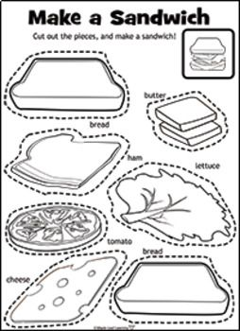

|  |  |  |  |
| --- | --- | --- | --- |
| **What’s the Beginning Blend?** | | | |
| Directions: Say the words for the pictures below. Listen to the first sound you hear. Write the blend for that sound on the line**. tr st pl** | | | |
| Car Semi-trailer Truck - Truck Clipart Tractor Trailer, HD Png ... | Free Stars Clipart, Download Free Clip Art, Free Clip Art on ... | C:\Users\Gabriela Castillo\AppData\Local\Microsoft\Windows\INetCache\Content.MSO\97F19E80.tmp | stick clipart - Clip Art Library |
| -------------------------------- | ------------------------------- | ------------------------------- | ------------------------------- |
| Planet Jupiter Png Download - Saturn Planet Clipart - 704x482 PNG ... | C:\Users\Gabriela Castillo\AppData\Local\Microsoft\Windows\INetCache\Content.MSO\46FB13CC.tmp | Black and White Electrical Plug Clip Art - Black and White ... | Free Free Trophy Clipart, Download Free Clip Art, Free Clip Art on ... |
| -------------------------------- | ------------------------------- | ------------------------------- | ------------------------------- |

|  |  |  |  |
| --- | --- | --- | --- |
| **What’s the Beginning Blend?** | | | |
| Directions: Say the words for the pictures below. Listen to the first sound you hear. Write the blend for that sound on the line**. tr st pl** | | | |
| Car Semi-trailer Truck - Truck Clipart Tractor Trailer, HD Png ... | Free Stars Clipart, Download Free Clip Art, Free Clip Art on ... | C:\Users\Gabriela Castillo\AppData\Local\Microsoft\Windows\INetCache\Content.MSO\97F19E80.tmp | stick clipart - Clip Art Library |
| -------------------------------- | ------------------------------- | ------------------------------- | ------------------------------- |
| Planet Jupiter Png Download - Saturn Planet Clipart - 704x482 PNG ... | C:\Users\Gabriela Castillo\AppData\Local\Microsoft\Windows\INetCache\Content.MSO\46FB13CC.tmp | Black and White Electrical Plug Clip Art - Black and White ... | Free Free Trophy Clipart, Download Free Clip Art, Free Clip Art on ... |
| -------------------------------- | ------------------------------- | ------------------------------- | ------------------------------- |

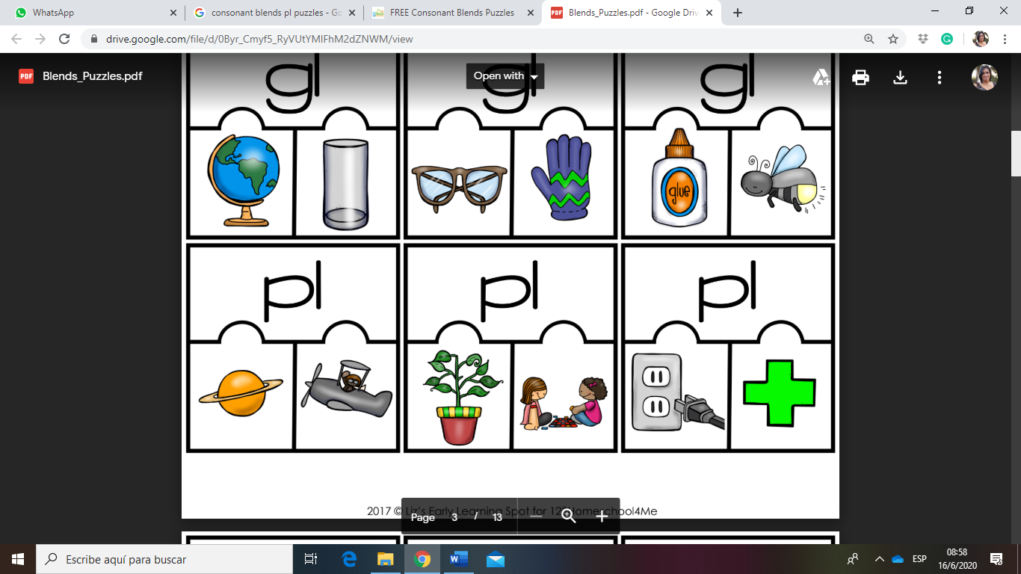

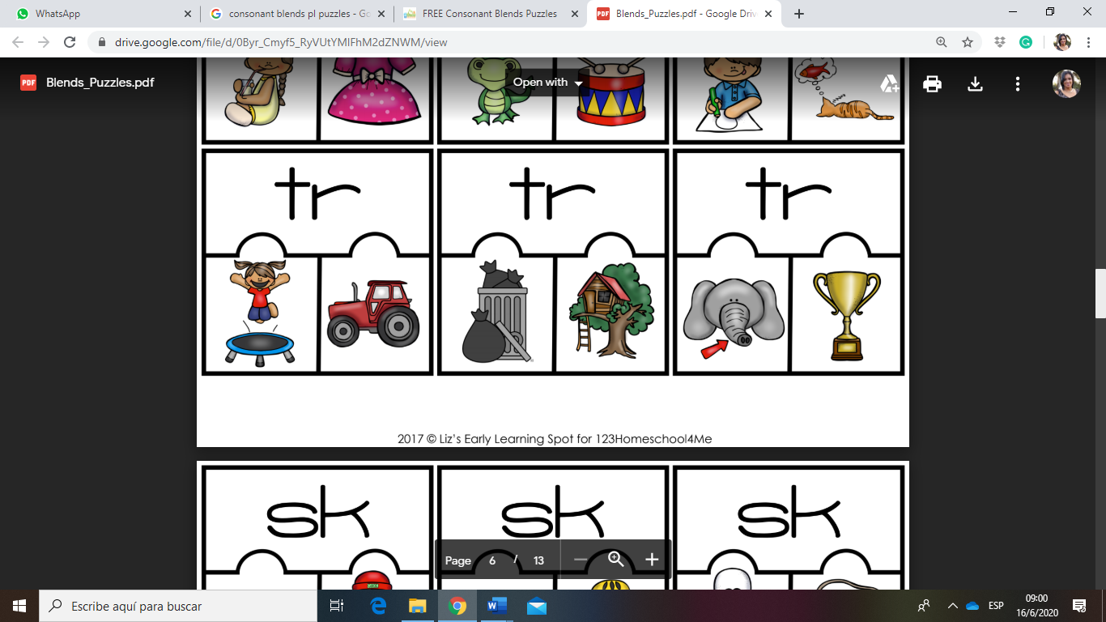

|  |  |  |  |  |  |  |  |  |  |
| --- | --- | --- | --- | --- | --- | --- | --- | --- | --- |
| **Term: Second** | | **Level: IV** | | | **Unit: 3** | | **Week: 4** | | |
| **Domain: Transactional** | | | **Scenario:** Farm to Table | | | **Theme:** May I have your order? | | | |
| **Enduring Understanding**: Fertile land and farming are necessary to have fresh food on the table and provide us with the ingredients  for a good meal. | | | | | | | | | |
| **Essential Question:** What does it take to have fresh food on our table? | | | | | | | | | |
| |  | | --- | | **Dimensions** | | **1.** **Ways of thinking ( X )** | | **2. Ways of living in the world ( )** | | **3. Ways of relating with others ( X )** | | **4. Tools for integrating with the world ( X )** |   **New Citizenship:** | | | | | | | | | |
| **Learn to Know** | | | **Learn to Do** | | | **Learn to Be and Live in Community** | | | |
| **Grammar & Sentence Frames**  Wh-questions with present simple   * What do you usually buy at the farmer’s market? * What do you usually order at the restaurant? * What do you like to have for breakfast/ lunch/ dinner?   Wh-questions with present continuous   * What are they doing?   -Where are you going?  **Vocabulary**  4. May I have your order?   * Waiter, Waitress * Cashier, Order * Menu, Breakfast * Lunch, Dinner * Main dish, Bill * Side dish   **Phonemic Awareness**  Practicing minimal pair sounds**: s / z**  **sip / zip**  **sue / zoo**  **place / plays**  **rice / rise**  **ice / eyes** | | | **Function**   * Expressing preferences for ordering food   **Discourse Markers**  Linkers: Sequential - past tense  First, then, after that, finally | | | **Psycho-social**   * Values the work of farmers   **Sociocultural**   * Ways of expressing gratitude   **Idioms/phrases**   * To be starving( to be very hungry) | | | |
| **Assessment Strategies & Evidences of learning**  **(Diagnostic, formative, summative)** | **Goals** | | **Pedagogical Mediation/ Didactic Sequence** | | | | | **Time** | |
|  |  | | **Pre-teaching**  **Routine:** Checking attendance, checking in with Ls, T posts the Essential Question on the board, Can Do’s, and class agenda, etc.  **Warm up:**  Learners sing the song “**Let’s go to the market”** <https://www.youtube.com/watch?v=k0Y3bYRC5QU> . Then, the learners list the food they saw in the video.  **Activation of prior knowledge**  The learners observe the teacher as he/she places a box on the desk. The teacher then writes on the board and asks learners **“What does your family usually buy at the farmer’s market? What do you buy at the farmer’s market?** Learners, in groups of four, brainstorm the name of different vegetables, fruits, dairy products, etc., their families buy at the farmer’s market. Then, the teacher takes the box on the desk and asks each learner to take a piece of paper from it. Each paper has the name of food people can buy at the farmer’s market. Learners get a blank sheet of paper, and they are asked to draw the type o food and paste it on the board. Learners review the name and pronunciation of each type of food.  **Modeling**  The teacher explains that the food we eat comes from a farm. People buy the vegetables and fruits at the farmer’s market and that food goes to our houses and to restaurants. That’s why we say the food goes from farm -to- table. Teacher explains to learners that in today’s class they are going to learn how to order food at the restaurant, but first the teacher asks:  ***When you go to a restaurant, what do you usually order?***  Teacher shows pictures of food people find at a restaurant as stimulus to the students, and then the teacher provides sample sentences:  *“I usually order a casado. Sometimes I order friend chicken and French fries.”*  Chicken Tenders with French Fries and Dipping Sauce by Linda ...The Costa Rican Casado | The Daily. October 2nd, 2019.  Then, some volunteers mention what they usually order at a restaurant: “ I *usually order…”*  Next, the teacher explains that now they are going to learn how to order food at a restaurant. To do so, learners first watch the following videos: <https://www.youtube.com/watch?v=49QFHWIky-k&feature=youtu.be> **May I take your order? Anything else? For here or to go. - English for Kids**<https://www.youtube.com/watch?v=IWMMkp35d6Y&feature=youtu.be> **May I take your order? I'd like a pizza. (At the Restaurant) - Easy English Dialogue** The teacher then writes a simple conversation on the board using the target structure. Leaners copy in their notebooks and repeat it after the teacher.  **A**: May I take your order?  **B:** Yes, I’d like spaghetti and salad.  **A**: Anything else?  **C:** I’d like a taco, please  **A:** Spaghetti, salad and taco. Right?  B: Yes, that’s right!  **Clarifying**  The teacher dresses up as she/he were a waiter/waitress. Then, sets up a table in front of the class simulating a restaurant. The teacher asks for two volunteers to sit at the table. Together with the teacher, the learners practice the conversation of how to order food at the restaurant.  More volunteers go to the front and the practice continues.  Next, a student is asked to take the role of the waitress/waiter to take the order of their classmates.  The learners in groups create a dialogue about ordering food in a restaurant based on a draft given by the teacher. They present their short conversations to the class.  <https://en.islcollective.com/english-esl-worksheets/grammar/questions-interrogative/may-i-take-your-order/51209>  May I take your order | | | | |  | |
| **R.2.** Locate important information in simple text.  **Indicators of learning**  Identifies vocabulary related to food.  Locates specific information in a short-written conversation | **R.2.** Locate important information in simple text (e.g., greeting on the bulletin board or times and dates on a class notice). | | **Written Comprehension**  **Pre-task**  The teacher introduces the goal of the lesson and reviews how to order food at a restaurant. Some volunteers go the front and present a short between a waiter and a customer at a restaurant. The teacher also reviews the past tense verbs: ate, drank, had.   * I ate a sandwich yesterday. I drank milk last night. * I had a taco for lunch.   **Task-rehearsal**  The teacher pastes the following conversation on the board:  **Waiter-** May I take your order?  **Oscar** - Yes.  I'd like a rice with chicken and a salad  **Waiter** -And what would you like to drink?  **Oscar** - I'd like a lemonade, please.  **Waiter** - And what would you like to order?  **José**- I'll take a hamburger and French fries.  **Waiter** - What would you like to drink?  **José**- – A coke, please.  **Waiter** - Would you like something for dessert?  **Oscar** - Yes, I'll have an ice cream cone, please.  Would you like something?  **José**-– Sure! I’d like a piece of chocolate cake.  The learners read the conversation with the teacher and then he/she writes on the board:  Oscar ate\_\_\_\_\_\_\_\_\_\_\_\_\_\_\_\_\_\_\_\_\_\_\_\_  He drank\_\_\_\_\_\_\_\_\_\_\_\_\_\_\_\_\_\_\_\_\_\_\_\_  For dessert, he had\_\_\_\_\_\_\_\_\_\_\_\_\_\_\_\_\_  José ate\_\_\_\_\_\_\_\_\_\_\_\_\_\_\_\_\_\_\_\_\_\_\_\_  He drank\_\_\_\_\_\_\_\_\_\_\_\_\_\_\_\_\_\_\_\_\_\_\_\_  For dessert, he had \_\_\_\_\_\_\_\_\_\_\_\_\_\_\_\_\_  The class is divided into groups of three. The groups work together reading the conversation and filling in the blanks with the corresponding answers. Teacher monitors and provides help if necessary. Two groups get together and compare their answers. Then, the answers are checked as a whole group.  **Task completion**  Learners, individually, read the following conversation and complete the chart.  **Dialogue: Ordering food at the restaurant**  **Instructions**: Read the dialogue below and then answer complete the chart.   |  | | --- | | **Waiter-** May I take your order?  **Brenda** - Yes.  I'd like the chicken and a side order of corn.  **Waiter** -And what would you like to drink?  Best Money Tips: Cut Your Restaurant Spending in Half**Brenda** - I'd like a cup of coffee, please.  **Waiter** - And what would you like to order?  **Carla** - I'll take the spaghetti and a salad.  **Waiter** - What would you like to drink?  **Carla** - Just water, please.  **Waiter** - Would you like something for dessert?  **Brenda** - Yes, I'll have the cake, please.  Would you like something?  **Carla** - No thanks.  I'm full. |  |  |  |  |  | | --- | --- | --- | --- | | **Person** | **She ate…** | **She drank…** | **For dessert, she had…** | | **Brenda** |  |  |  | | **Carla** |  |  |  |   **Task assessment**  The teacher plays “True and False” based on the conversations presented previously. Learners stands up if the statement the teacher says is “True” or remain sit, it if it “False”.  Leaners assess their achievement of the goal. | | | | |  | |
| **SI.1.** Asks others about what they like to eat or drink.  **Indicators of learning**  Formulates questions correctly.  Asks others about their eating preferences for breakfast, lunch, and dinner. | **SI.1.** ask others about what they like to eat or drink. | | **Oral Production**  **Pre-task**  The teacher introduces the goal of the lesson  Teacher reviews “ I like” and “ I don’t like” by using the video ‘ **Animated-Read-Aloud: “I like and I don’t like”** <https://www.youtube.com/watch?v=nE8ttvPACeg>.  Teacher introduces the words breakfast, lunch, dinner, and snack. He/she explains the times when we usually have our means.  Study English Online: Food: breakfast lunch dinner snack full-page ...  Then, the teacher writes on the board the following questions and answers and invites learners to repeat after him/her.  “***What do you like to have for breakfast?*** *I like to have pinto, eggs, cheese, and orange juice for breakfast.*  ***What do you like to have for lunch?*** *I like to have rice, beans, chicken, and salad**for lunch.*  ***What do you like to have for dinner?*** *I like to have tuna fish, tomato and rice for dinner.*  **Task-rehearsal**  Teacher ask learners what they and their family prefer to eat for breakfast, lunch and dinner. Volunteers take turns to answer.  After that, learners create their own vocabulary picture dictionary according to what they like or dislike for breakfast, lunch or dinner and then share it in front of the class.  *For breakfast, I like to have\_\_\_\_\_\_\_\_\_\_\_\_\_\_\_\_*  *For lunch, I like to have\_\_\_\_\_\_\_\_\_\_\_\_\_\_\_\_*  *For* dinner, *I like to have \_\_\_\_\_\_\_\_\_\_\_\_\_\_\_\_\_*  **Task completion**  Learners use and info-gap activity to practice asking their classmates what they like to have for breakfast, lunch, and dinner. Each learner gets a handout. Learners must mingle around asking three of their classmates their preferences for breakfast, lunch, and dinner. Some of the learners report their findings to the group.   |  |  |  |  |  | | --- | --- | --- | --- | --- | | **Instructions**:  Ask three of your friends what they like to have for breakfast, lunch and dinner. Write their answers in the corresponding space. Then, report back to the class. | | | | | | **What do you like to have for…?**  **I like to have \_\_\_\_\_\_\_ for\_\_\_\_\_** | | | | | | **Meal** | **Me** | **Friend 1** | **Friend 2** | **Friend 3** | | **Breakfast** |  |  |  |  | | **Lunch** |  |  |  |  | | **Dinner** |  |  |  |  | | **Now, report back to the class.** | | | | |   **Task assessment**  The group assesses their achievement of the goal using the traffic light technique.  [**http://bhsfeedback.weebly.com/traffic-lights.html**](http://bhsfeedback.weebly.com/traffic-lights.html)  Red: I don't get it! I need help understanding.   Yellow: I think I understand but need a little support. Green: Got it! Could help teach another student (yellow). | | | | |  | |
| **SP.3.** Presents with a group, a topic sentence and two to three details  **Indicators of learning:**  Identifies everyday actions.  Talks about what people are doing, using complete sentences.  Talks about where people are going, using complete sentences. | **SP.3.** present with a group, a topic sentence and two to three details | | **Oral Production**  **Pre-task**  The teacher shares the goal of the lesson.  Learners observe the teacher as she pastes the picture of people doing different actions on the board. Then, the teacher writes on the board:   * **What is he/she doing?** * **What are you/they/we doing?** * **Where is he/she going?** * **Where are you/they/we going?**   Using the pictures, the teacher explains the meaning of each question and invites students to repeat after him/her.  **C:\Users\Gabriela Castillo\AppData\Local\Microsoft\Windows\INetCache\Content.MSO\41C5871B.tmp**Clipart Cook Picture, Download Free Images, Free Clip Art on ...  **What is she doing? What are they doing?**  She is cooking They are eating pizza.  Family Walking In The Park Royalty Free Cliparts, Vectors, And ...Happy Man Shopping With Credit Card - Download Free Vectors ...  **Where is he going? Where are they going?**  He is going to the supermarket. They are going to the park.  **Task Rehearsal**  **Learners play ‘Drawing race’.** Learners race to draw a picture of a sentence they hear e.g. “Maria is eating at a restaurant”. The teacher gives points for the first one that matches the description and/ or the best picture.  Pictures of people doing different actions are pasted all over the classroom. Learners take turns to go to the front, say a sentence and another student runs to look for the corresponding picture.  **Task- completion**  The class is divided into groups of four. Each group gets poster paper and markers. They are asked to draw a town and people doing different activities (at least 4). The poster is called **“Everybody in my town is busy.”** Learners present their posters orally to the group. They start their presentation by saying:  ***Everybody in my town is busy. There is a woman planting vegetables. A man…***  Teacher provides feedback on learners’ performance and asks follow up questions using the target questions: *What is he/she doing? Where is he/she going?*  **Task Assessment**  Learners think of a city and the activities people are doing there. They write 5 sentences describing those actions:  Example:   * Two friends are going to a restaurant. * A girl is eating an ice cream. * A woman is planting flowers.   The class is then divided into pairs. Learners take turns to read their sentences to each other and try to draw them from the description. Leaners compare the sentences to the picture drawn.  Leaners self-assess their performance by using their fingers:  **1 finger**: I need help.  **2 fingers**: I did it, but I need to practice more.  **3 fingers**: I did it correctly. | | | | | |  |
| **R.PA.1.** Reads words and sentences blending English graphemes and phonemes.  **Indicators of learning**  Identifies the difference between minimal pairs /s/ and /z/ phonemes when spoken by others.  Pronounces minimal pairs /s/ and /z/ phonemes correctly.  Reads minimal pairs words containing /s/ and /z/ phonemes correctly. | **R.PA.1.** decode English graphemes and phonemes using knowledge of word parts, syllabification and phonemic awareness. | | **Written Comprehension**  **Pre-task**  The teacher shares the goal of the lesson. The teacher explains that minimal pairs are words that vary by only a single sound, for example /s/ and /z/. Teacher provides examples and asks learners to repeat after her/him.   |  |  | | --- | --- | | **/s/** | **/z/** | | Refreshment- Retro Cartoon Girl Teen Vector Illustration Stock ... | Zip Clipart Group - Zip Images Clip Art | Transparent PNG Download ... | | **sip** | **zip** | | Woman clip art - Woman clipart photo - NiceClipart.com | Kids At The Zoo Clipart | +1,566,198 clip arts | | **Sue** | **zoo** | | water sink clipart - Clip Art Library | Industrial Fasteners - Nuts and Bolts - Grainger Industrial Supply | | **sink** | **zink** | | Ice cubes Clipart | k5913451 | Fotosearch | Eyes Looking Clipart Images Pictures Becuo (With images) | Eyes ... | | **ice** | **eyes** | | Rice Clipart Cooked Rice - Jasmine Rice #1251985 - PNG Images - PNGio | Morning sunrise clipart 9 » Clipart Station | | **rice** | **rise** |   **Task Rehearsal**  Learners play ‘**Run and Grab’**. The teacher sticks the cards with the minimal pair on the board. The class is divided into two teams, and then a member of each team stands at the back of the room, looking down an aisle at the board. The teacher calls one of the minimal pairs out, and the pair of students races to the front to touch the correct words on the board or grab the appropriate flashcards. Student from the winning team could have a turn calling the words for others to run.  **Task completion**  Teacher divides the group into pairs to play **‘Running Dictation’ One** student runs to read the words from somewhere farther away, like on the wall outside the classroom. They then dictate to the other student who writes them down. The teacher monitors learners’ performance when reading the target words: The difference between words with /s/ sound and /z/ sound. Learners switch places and it is now time for the other student to dictate.  **Task assessment**  Learners play **‘Crumple and Shoot Basketball’** The minimal pair words are written on pieces of (scrap) paper. Students are lined up in two teams. In turn, the front student picks up the paper and reads the word. If it’s read correctly, they then crumple it up and throw it into a basket a set distance away. (Getting it into the basket wins another point.)  Learners work on self and peer assessment. Whole class assesses their achievement of the goal. | | | | | |  |
| **Integrated Mini-Project** | | | | | | | | **Time** | |
| * **Planning:**The class is divided into groups of three. Learners are told they are going to prepare a Cooking Show Skit to show how to make a simple recipe. The groups find a recipe for a meal of their choice. * **Creating:** Learners write the ingredients and quantities they need, the utensils, and the steps (in a sequential order) to prepare the recipe. * **Rehearsing:** Learners rehearse their Cooking Show. * **Participating:** Learners present their Cooking Show to the class. The teacher can record each presentation in a video (if parents agree) and the videos can be presented to the whole class. | | | | | | | | Group presentations can be week 5 or 6. | |
| **Reflective Teaching** | | | | | | | | | |
| What worked well | | | | What didn’t work well | | | | How to improve | |
| **Enduring Understanding Reflection** | | | | | | | | | |
| How well did the learners progress in their understanding of the Enduring Understanding? | | | | | | | | | |
| **Week Plan Self-Assessment** | | | | | | | | | |
| At the end of the week, T guides the learners to check their progress using the checklist below. (Can be translated into Spanish if needed to ensure Ls’ understanding.) | | | | | | | | | |

|  |  |  |  |
| --- | --- | --- | --- |
| **Learner Self-Assessment** | | | |
| ***I can…*** | ***Yes*** | ***Sort of*** | ***No. Help!*** |
| Locate specific information in a short-written conversation |  |  |  |
| Ask others about their eating preferences for breakfast, lunch, and dinner. |  |  |  |
| Talk about what people are doing, using complete sentences. |  |  |  |
| Talk about where people are going, using complete sentences. |  |  |  |
| Read minimal pairs words containing /s/ and /z/ phonemes correctly. |  |  |  |

|  |
| --- |
| The Ultimate Hamburger recipe | Epicurious.com |
| Recipes from Costa Rica - Costa Rican Food Recipess |

|  |
| --- |
| The Costa Rican Casado | The Daily. October 2nd, 2019. |
| Tacos a la tica | Costa rica comida, Comida |

|  |
| --- |
| Pasti Sedap French Fries | Unilever Food Solutions |
| Pizza with Pepperoni, Mushrooms, Onions and Peppers HD Wallpaper ... |

|  |
| --- |
|  |
| Espaguetis en salsa rosada - Fácil |

|  |
| --- |
| Fried Chicken Recipe: How to Make Fried Chicken at Home| Simple ... |
| Foto de La Hendija Sabrosa, Alajuela: Gallo de Picadillo de Papa ... |

|  |
| --- |
| DON'T GO HEAVY ON THE MUSTARD - Happier Than A Billionaire |
| 10 Ways to Save Money Buying Fresh Produce - Fruits & Vegetables |

|  |
| --- |
| An Elderly Farmer Is Selling Vegetables on the Farm Market by ... |
| Fruit and vegetables: Five-a-day can cost as little as 42p | Daily ... |

|  |
| --- |
| Where the 'fat' tables are in restaurants |
| Cops who drove down pedestrian walkway at a farmers market blasted ... |

|  |
| --- |
| WWII-era 'victory gardens' make a comeback amid coronavirus | Crosscut |
| A Farmer Breeds and Cows Stock Footage Video (100% Royalty ... |

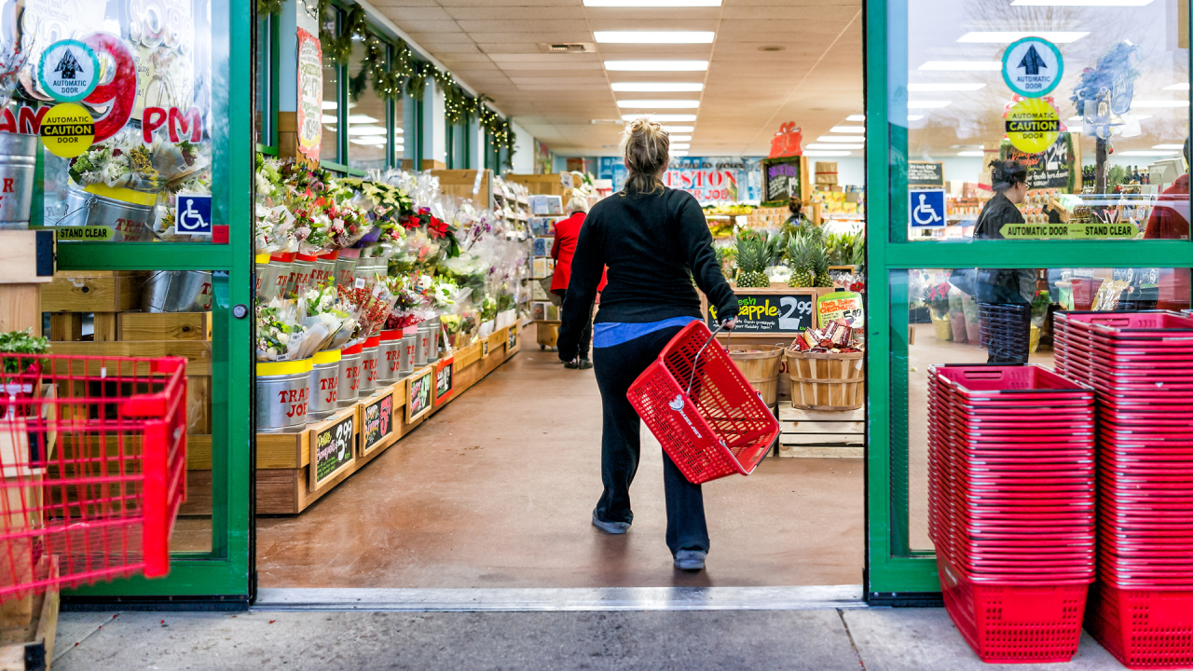

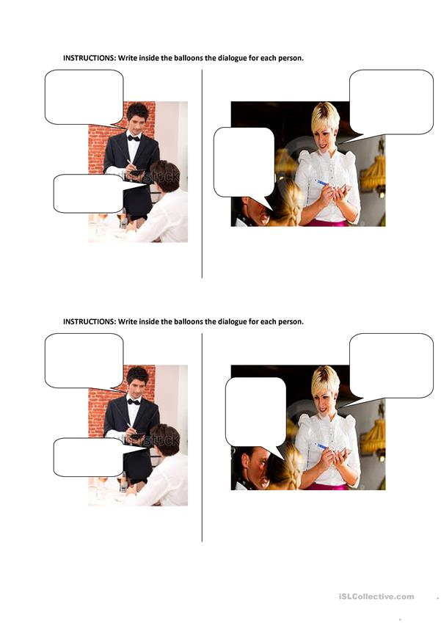

**Dialogue: Ordering food at the restaurant**

**Instructions**: Read the dialogue below and then answer complete the chart.

|  |
| --- |
| **Waiter-** May I take your order?  **Brenda** - Yes.  I'd like the chicken and a side order of corn.  Best Money Tips: Cut Your Restaurant Spending in Half**Waiter** -And what would you like to drink?  **Brenda** - I'd like a cup of coffee, please.  **Waiter** - And what would you like to order?  **Carla** - I'll take the spaghetti and a salad.  **Waiter** - What would you like to drink?  **Carla** - Just water, please.  **Waiter** - Would you like something for dessert?  **Brenda** - Yes, I'll have the cake, please.  Would you like something?  **Carla** - No thanks.  I'm full. |

|  |  |  |  |
| --- | --- | --- | --- |
| **Person** | **She ate…** | **She drank…** | **For dessert, she had…** |
| **Brenda** |  |  |  |
| **Carla** |  |  |  |

|  |  |  |  |  |
| --- | --- | --- | --- | --- |
| **Instructions**:  Ask three of your friends what they like to have for breakfast, lunch and dinner. Write their answers in the corresponding space. Then, report back to the class. | | | | |
| **What do you like to have for…?**  **I like to have \_\_\_\_\_\_\_ for\_\_\_\_\_** | | | | |
| **Meal** | **Me** | **Friend 1** | **Friend 2** | **Friend 3** |
| **Breakfast** |  |  |  |  |
| **Lunch** |  |  |  |  |
| **Dinner** |  |  |  |  |
| **Now, report back to the class.** | | | | |

Créditos

Dirección de Desarrollo Curricular

Anabelle Venegas Fernández, Jefatura Departamento de Primero y Segundo Ciclos

Elaboración:

Ana Isabel Campos Centeno

Yaudy Ramírez Vásquez,

Asesoras Nacionales de Inglés, Departamento de Primero y Segundo Ciclos

Gilberto Víquez Córdoba,

Asesor regional de inglés, Dirección Regional de Educación de Cartago

MSc. María Gabriela Castillo Hernández

Asesora Regional de inglés, Dirección Regional de Educación de San Carlos

Equipo de docentes colaboradores,Dirección Regional de Cartago

Marco Alvarado Barboza, Escuela Emilio Robert / Winston Churchill S

Mauren Brenes Solano, Escuela Ricardo Jiménez O / Escuela de Guatuso

Maritza Cedeño Ortega, Escuela Ricardo Jiménez O

Isabel Granados Rivera, Escuela Ricardo Jiménez O

Yolette Portugués Bolaño, Escuela Ascensión Esquivel

Greivin Sánchez Solano, Escuela Orosi